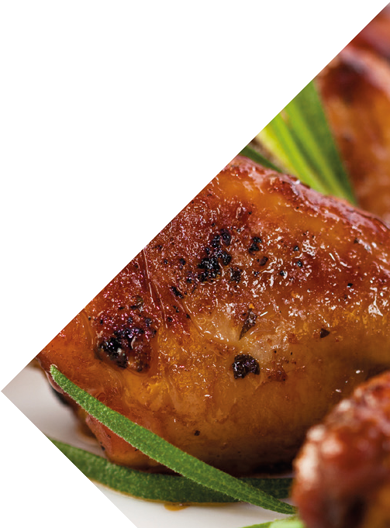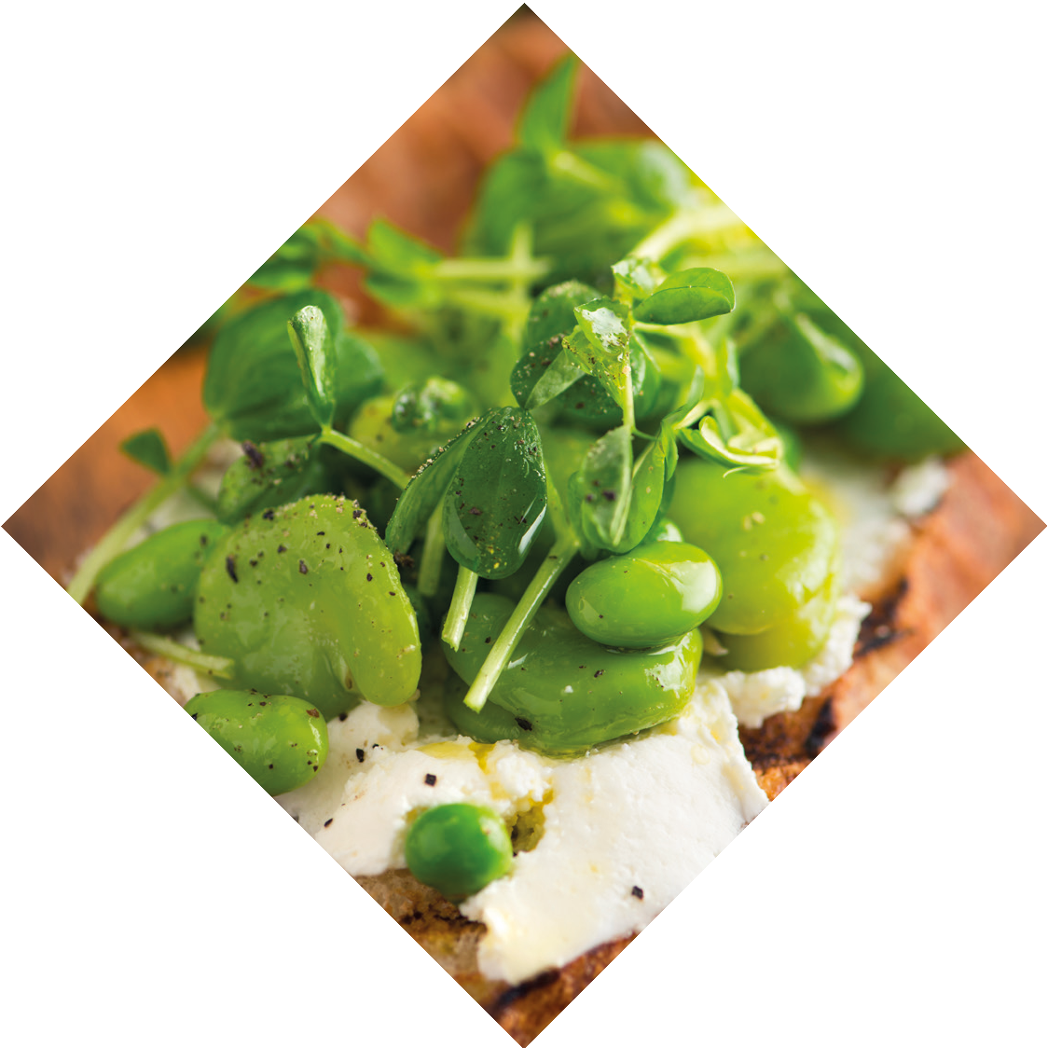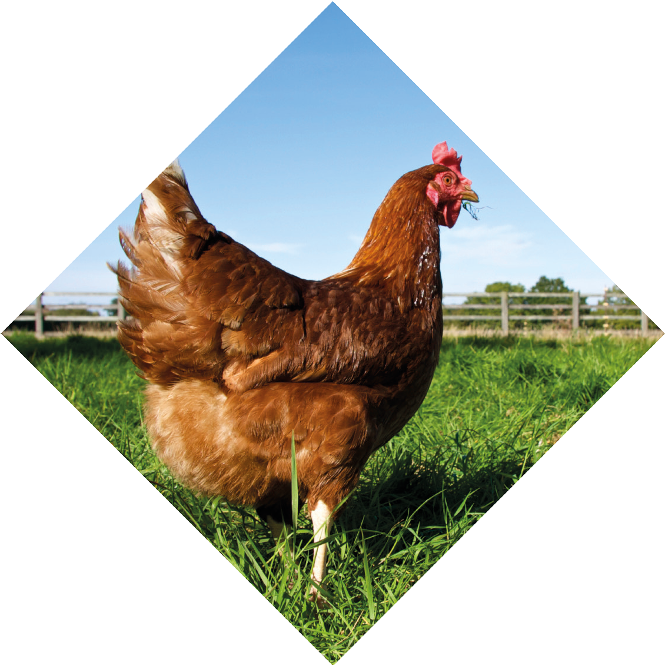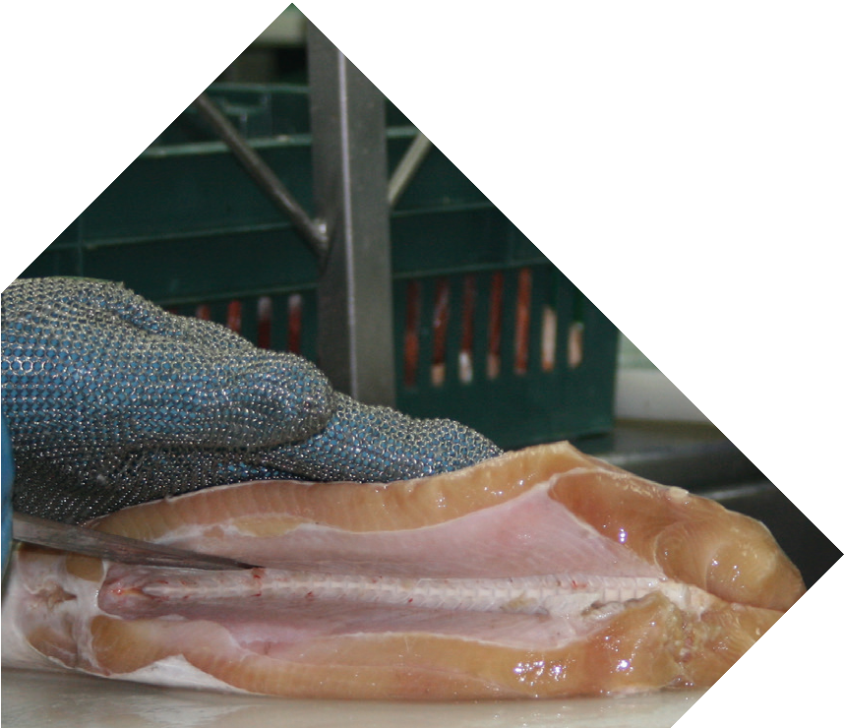

Annual Report 2018–19

Contents
Letter of compliance 2
Public availability 3
Message from the Chair of the Board 4
Message from Chief Executive Officer 5
2018-19 performance snapshot 6
About us 7
How we verify industry compliance 8
Strategic priorities and model practices 9
Our accreditation base 10
Strategic priority #1 11
Verification & compliance 14
Strategic priority #2 15
Notifications & response 20
Strategic priority #3 21
Safe Food Board 25
Organisational arrangements 28
Corporate governance practices 31
Corporate planning and performance management 32
Internal audit charter 32
Audit and risk committee 32
Public sector ethics 33
Code of conduct 33
Workplace health and safety 34
Additional information 35
Our financial position 37
Attachment A compliance checklist 65
Glossary 68
Acronyms 69
Contact us 70

Letter of compliance

The Honourable Mark Furner MP
Minister for Agricultural Industry Development and Fisheries GPO Box 46
BRISBANE QLD 4000

Dear Minister

I am pleased to present the Annual Report for 2018-2019 and financial statements for Safe Food Production
Queensland. I certify that this Annual Report complies with:

- the prescribed requirements of the Financial Accountability Act 2009 and the Financial and Performance Management Standard 2009, and

- the detailed requirements set out in the Annual Report Requirements for Queensland Government Agencies.

A checklist outlining the annual reporting requirements can be accessed at page 65 of this Annual Report or at www.safefood.qld.gov.au.

Yours sincerely

Debbie Best Chair
Safe Food Production Queensland

Public availability

This Annual Report is available on our website at www.safefood.qld.gov.au and in hard copy on request using the contact details below.

Stakeholder feedback is important to us and contributes to improving the value of future annual reports for our readers. We welcome your comments on this report. You can contact us at:

Email: info@safefood.qld.gov.au Phone: (07) 3253 9800
Freecall:1800 300 815 (QLD only)

Fax: (07) 3253 9810

Post: Safe Food Production Queensland PO Box 221
GREENSLOPES QLD 4120

Safe Food Production Queensland is committed to providing accessible services to Queenslanders from all culturally and linguistically diverse backgrounds. If you have difficulty in understanding the Annual Report, you can contact us on either (07) 3253 9800 or 1800 300 815 and we will arrange for an interpreter to effectively communicate the Report to you.

ABN 94 790 873 787
Bib ID 4561622
ISSN 2652-256X (Print) ISSN 2652-2578 (Online)

Message from the Chair of the Board

It is with much pleasure that I present the 2018-2019 Annual Report for Safe Food Production Queensland (Safe Food).

I was appointed as Chair of Safe Food in May 2019 and look forward to working with my fellow Directors to optimise the role of the Agency within its brief as a State regulator.

Safe Food is a statutory body that reports to the Minister for Agricultural Industry Development and Fisheries and is responsible for delivering risk-based food safety outcomes for the primary production and processing sector in Queensland.

Safe Food has seen an increase in the number of accreditations issued across the State. This is despite the extreme weather conditions experienced throughout much of Australia and the commercial drive which has seen many farming enterprises consolidate into larger entities.

During the year, a number of Government reviews reported their findings and decisions which will have an impact on
Safe Food’s development of the Board’s Strategic Plan and subsequent work program over the next few years. Of particular note:
- Queensland Audit Office report, Managing consumer food safety in Queensland.

- Food Standards Australia New Zealand (FSANZ) Report on the 2018 Strawberry Tampering Incident.

- Listeria Outbreak Investigation - Summary Report for the Melon Industry, October 2018 by the New South Wales Department of Primary Industries, and

- The Australian and New Zealand Ministerial Forum on Food Regulation decision to request FSANZ to investigate options to manage food safety risks in high risk horticulture products.

The Board, Executive and Safe Food staff are looking forward to working collaboratively to implement a Strategic Plan that will
deliver certainty about food safety across the food supply chain through a science and risk-based regulatory framework.

This Report highlights the positive outcomes from Safe Food’s implementation of food safety systems in Queensland, and how these results contribute to the national food safety network.

The Board would like to thank the Safe Food team for their dedication and commitment.

Debbie Best Chair
Safe Food Production Queensland

Message from Chief
Executive Officer

During the lengthy recruitment period for the role of permanent Chief Executive Officer (CEO), two people; Mr Alex Baker and Dr Jacqui King, acted in the role. Both contributed significantly to Safe Food’s operational and future directions during their time at the helm. We thank them for their efforts and commitment. I would also like to acknowledge Libby Homer’s work in leading the Board during this same period.

This Annual Report testifies to the sustainability of the regulatory models and tools that Safe Food has introduced and implemented over recent times. The industries we work with have continued to share information with Safe Food about their performance, and the integrity of our regulatory system is built on this trust.

Since its formation, Safe Food has focused outwardly to ensure its service to industry and government has always been of a high standard. This year we have applied considerable resources to updating and, where appropriate, documenting our administrative processes and policies to ensure that we now comply with State Government’s minimum standards and best practice in corporate governance. We will supplement this in the next year by carrying out a planned audit schedule to measure our compliance with these administrative guides. Where appropriate, these policies and guidelines have been placed on our website (and are available in other forms) to advise the public of our commitments.

In May this year, the State Government introduced a Queensland Government Regulatory Performance Framework and, like all other regulators, Safe Food is required to report its performance in delivering regulation against the five best practice principles it contains. It is satisfying to see the great work we have been doing engaging with industry and adopting the use of technology and new regulatory approaches has allowed us to report a strong alignment between the performance framework and Safe Food’s activities in the first reporting year.

Late last year the Ministerial Forum on Food Regulation asked Food Standards Australia and New Zealand (FSANZ) to consider the best ways to manage the food safety risks associated with high risk horticultural products. Safe Food will work with other jurisdictions and Industry to best answer this request. This is a sector we have partially engaged with over recent years and we are looking forward to the opportunity to work with this sector which is dispersed widely across the state.

The current Strategic Plan concludes this year, and during the year we have considered how we have performed and what challenges we still need to meet in the future. We are excited about the success that the Strategic Plan has created for us in utilising data-sharing tools which have created a new relationship between Safe Food and the industries we work with, and we will bring these case studies to formulation for the next Strategic Plan.

Safe Food continues to work diligently on the national level in the food regulatory system where we emphasise good
regulatory practice and early identification and response to risks by industry.

It is pleasing to note that at the end of the financial year we have achieved a better budget position than expected and a
sound audit report.
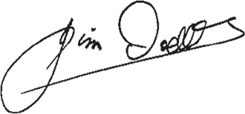

Jim Dodds CEO
Safe Food Production Queensland

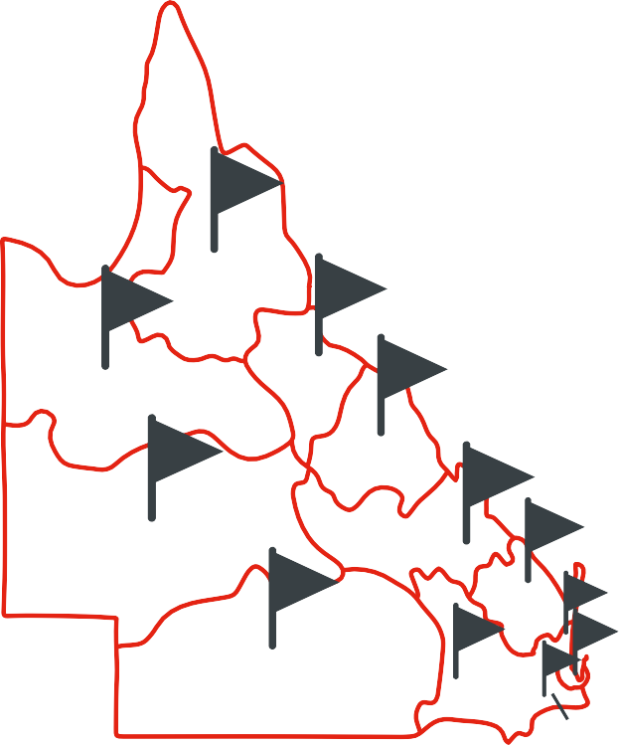2018-19 PERFORMANCE SNAPSHOT
ACCREDITATIONS
ACCREDITATIONS
BY SCHEME
522 BY REGION
FAR NORTH
314
140
436 139 1103 5913 8
NORTHERN 274
NORTH WEST
NUMBER OF AUDITS
184
MACKAY
CONDUCTED
406
3308
556
CENTRAL WEST
FITZROY
383
SUNSHINE COAST
WIDE BAY- 431 BURNETT
904
88
SOUTH WEST
OTHER
DARLING DOWNS
2528
394 475
GOLD COAST
BRISBANE
MORETON
NUMBER OF ASSESSMENTS
4210
NOTIFICATIONS & COMPLAINTS BREAKDOWN
100
100 94
89
APPROVED
AUDITORS
69
65
50
47
19
16
5
0
24
WITHIN SAFE FOOD
14
THIRD- PARTY

About us

Queensland’s reputation for premium, high-quality products depends upon maintaining standards that meet consumer expectations in Australia and in overseas markets.

As the statutory body responsible for regulating food safety in Queensland’s food production and processing sectors, Safe Food Production Queensland (Safe Food) plays an important role in verifying that food standards are met, and that consumer confidence is maintained.

Safe Food regulates and operates in accordance with the Food Production (Safety) Act 2000, using a science and risk- based regulatory framework, and reports to the Minister for Agricultural Industry Development and Fisheries.

Safe Food’s core business is the development and implementation of food safety policy and standards through outcomes-focused Food Safety Schemes for the meat, dairy, egg, seafood and horticulture (seed sprouts) sectors. Our collaborative approach to food regulation ensures that:

  - Safe Food is a responsive Queensland Government agency that continually innovates to improve its regulatory model,

  - Queensland’s food production and processing sectors are provided with easy-to-use services that reduce
regulatory burden, while ensuring food safety regulatory requirements are satisfied, and

  - Ideas are generated to support food businesses, inform a holistic approach to regulation and are responsive to national policy initiatives.

Our vision is for Safe Food to remain an influential agency for change by putting a culture of food safety at the heart of every accredited food business in Queensland. Therefore, our regulatory framework has a focus on influencing behaviour as an important element of sustaining compliance.

To support collaboration and information sharing, Safe Food has engagement and consultation mechanisms for a diverse range of production sectors. By working in partnership with industry, Safe Food is able to develop and adopt simple, practical ways of addressing food safety requirements.

As food safety is the basis for protecting public health and maintaining confidence in trade of food commodities, Safe Food contributes to the Queensland Government’s objectives outlined in Our Future State: Advancing Queensland’s Priorities.

Through its regulatory activities, Safe Food assists in managing the food safety risks of food production, thereby helping to assure the continuous supply of safe and fresh food to help keep Queenslander’s healthy and regions prosperous.
Safe Food also provides certainty about food safety through the food supply chain by its regulatory framework. This
gives consumers confidence and facilitates an environment that sustains economic growth.

How we verify industry compliance

Under each Food Safety Scheme, businesses undertaking specified activities are required to hold an accreditation issued under the Food Production (Safety) Act 2000 and operate in accordance with their Safe Food approved food safety program or management statement. This documentation details how a business manages food safety risks during production. Safe Food publishes guidance documents to assist businesses to achieve compliance, share knowledge of best practice, provide greater understanding of requirements and promote greater food safety awareness across industry sectors.

Safe Food recognises the dynamic commercial and consumer environments in which accredited businesses operate and offers a range of monitoring methods, providing businesses with greater flexibility in how they demonstrate compliance with regulatory requirements.

Audits remain an important monitoring tool and a central aspect of Safe Food’s Compliance Policy. However, they can be costly in terms of time and money and have limitations as a method of indicating sustained compliance and identifying poor behaviour and culture. Therefore, other monitoring approaches have been developed, introduced and refined over time, based on the experiences of Safe Food and food businesses. This includes Safe Food’s Compliance Assessment System (CAS) and Central Information Management System (CIMS).

Under Safe Food’s Compliance Policy, formal enforcement tools (such as compliance notices and penalty infringement notices) are used as a last resort but may be required in certain instances to ensure compliance and protect public health.

Central Information Management System (CIMS)
CIMS was designed and implemented to analyse data supplied by industry, in some cases against agreed performance targets at key points in food production systems.

Collectively, this approach describes our methodology to monitor performance against a ‘food safety baseline’ that represents a stable and consistent individual food production system.

CIMS can facilitate through-chain monitoring of production systems, allowing industry to demonstrate that it is meeting key targets. By using information that is already being collected, it also serves to reduce compliance costs and regulatory burden.

Supplementing on-site monitoring with remote information-sharing provides regular and timely indicators on individual business’ production systems that promote proactive engagement between Safe Food and businesses.

Compliance Assessment System (CAS)
Safe Food has formally recognised culture as a driver for better food safety outcomes since 2014-15. CAS is an electronic platform that incorporates technology for assessing food safety compliance.
Compared to inspections or audits, this provides a snapshot of a business’ awareness of, provision for, and commitment to food safety. These are the key indicators of a business culture that promotes food safety and can achieve sustained compliance.

The process also enables accreditation holders to showcase the practices used within the business to support food safety.

Strategic priorities and model practices

Safe Food’s Statement of Strategy 2015-2020 outlines three strategic priorities and their key objectives, success indicators and expected outcomes. Together, these aim to achieve a balance between responsible regulation (consumer expectations) and the individual responsibility of businesses to demonstrate a culture that supports and promotes food safety.

Safe Food’s long held culture of working with industry on innovative approaches to demonstrate compliance has placed both the businesses and the agency in a strong position within a rapidly evolving competitive environment.

In early 2019, the new Queensland Government Regulatory Performance Framework was incorporated into the Better Regulation Strategy. The performance framework includes five model practices and supporting principles. The current alignment between Safe Food’s strategic priorities and the performance framework’s model practices are shown below.
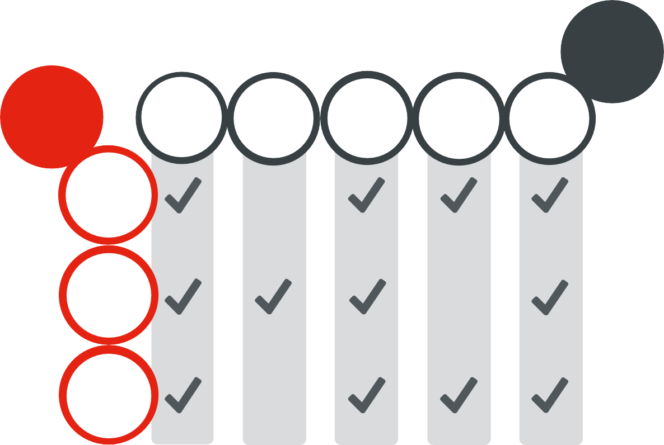
Regulator Model Practices
Our Strategic Priorities
Regulatory activity is proportionate to risk and minimises unnecessary burden
Consult and engage meaningfully with stakeholders
Provide appropriate information and support to assist compliance
Commit to continuous improvement
Be transparent and accountable in actions
Ensure the Queensland food safety system is affordable, sustainable and continually improving
Work in partnership with all stakeholders in the food chain to facilitate compliance with food standards
Ensure that Safe Food is responsive, efficient, effective and delivers value for money

This report highlights Safe Food’s alignment between the performance framework, Safe Food’s activities and success indicators, thereby forming the agency’s annual reporting against the framework.

Sources
Safe Food’s Statement of Strategy 2015-2020 is available on our website www.safefood.qld.gov.au

Queensland Government Guide to Better Regulation is available at www.treasury.qld.gov.au

OUR ACCREDITATION BASE

NUMBER OF ACCREDITATIONS | ACCREDITATIONS BY SCHEME
ACROSS
QUEENSLAND
7599 | 436 139 1103 5913 8
 | ACCREDITATIONS BY
 | RISK CATEGORY
 | 515 1009 6075
 | HIGH MEDIUM LOW
NEW APPLICATIONS | 165
1056 | ACCREDITED UNDER A PREFERRED SUPPLIER  ARRANGEMENT
APPROVED
EXPORT ACCREDITED
157 BUSINESSES
APPROVED AUDITORS
24 14 | BY SCHEME
WITHIN THIRD-PARTY
SAFE FOOD | 17 5 77 58 0

Strategic priority #1
Ensure the Queensland food safety system is affordable, sustainable and continually improving

Strategic Priority Success Indicators

Food safety

Related Regulator Model Practices
Be transparent and accountable in actions

To achieve

regulation that
is transparent, accountable and innovative
Commit to continuous improvement Consult and engage meaningfully with stakeholders

this we are

Scientific analysis informs risk management approaches aimed at improving food safety and health promotion

Rapid risk assessment capability to support improved food incident management activities

Ensure regulatory activity is proportionate to risk and minimises unnecessary burden
Provide appropriate information and support to assist compliance Commit to continuous improvement

Ensure regulatory activity is proportionate to risk and minimises unnecessary burden
Provide appropriate information and support to assist compliance
Using notification reporting processes to inform regulatory approaches and priorities Conducting or obtaining scientific risk assessments as the basis for risk management decisions
Seeking cost effective compliance solutions for the food sectors

Safe Food uses scientific advice and a risk assessment approach to inform risk management and enforcement
decisions.

During 2018-19, Safe Food issued over 8200 accreditations. As at 30 June 2019 there were 7599 open accreditations, including 1056 new approved applications. All current accreditations are listed on Safe Food’s online accreditation register (also known as the Food Business Register), including businesses operating under a Preferred Supplier Arrangement (PSA). Under a PSA, these businesses only supply to one customer, usually a large commercial processor within their industry. To reduce regulatory burden and unnecessary costs on these businesses, Safe Food works directly with commercial processors to verify compliance of their PSAs.

Safe Food has also continued to work with the Australian Department of Agriculture (DoA) under agreed arrangements to reduce duplication of regulatory effort on export businesses that hold both a Safe Food accreditation and export registration issued by DoA.

As shown in the case studies highlighted under this priority, we are continuing to use a scientific approach that is evidence-based, together with ongoing industry engagement and the use of technology, to underpin advice to our stakeholders on food safety measures.

Case study 1
Reliability in poultry carcase hygiene

Each week, Queensland’s 13 poultry processors produce approximately 2.6 million birds. Safe Food and the Queensland poultry meat industry identified areas in the supply chain where if industry-agreed, best practice performance targets were met, hygiene of poultry carcases would improve.

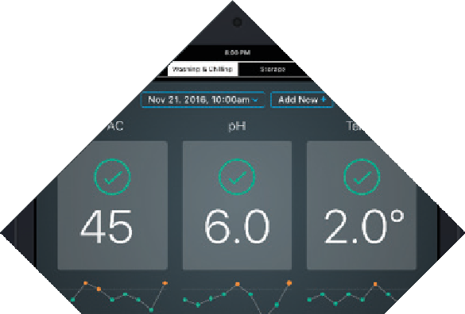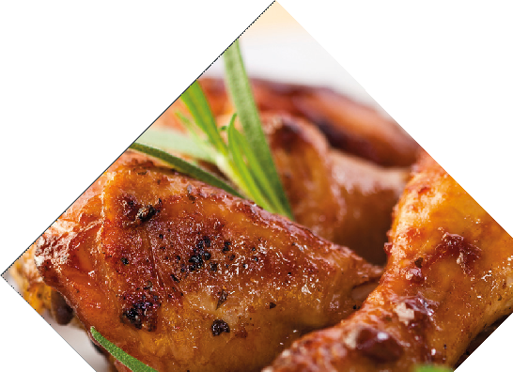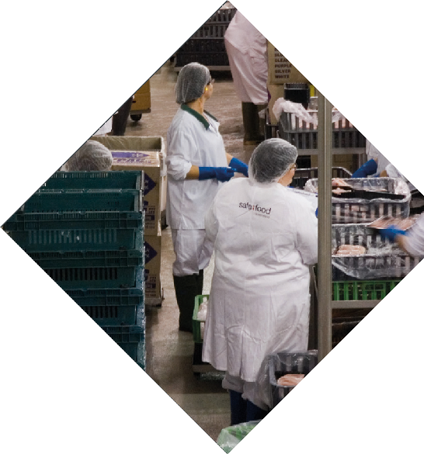Through active engagement with industry, a digital application was developed to collect food safety data in real- time, which feeds into a live dashboard that both poultry processors and regulators can view.

Processors are alerted if there are significant variations from performance targets so they can improve
their responsiveness which has improved compliance and also reduced product wastage.

Live reports also allow both businesses and Safe Food to make more accurate risk assessments based on real-time data.

The poultry hygiene criteria developed by Safe Food is now being implemented nationally as a key deliverable of Australia’s Foodborne Illness Reduction Strategy 2018-2021+.

Case study 2
System verification study of
red meat abattoirs

In 2018, Safe Food visited 42 domestic only supply red meat abattoirs in Queensland to assess food safety controls and identify opportunities for improvement.

A high level of compliance was observed with food safety legislation, with variability in the way that the performance of each system was monitored.

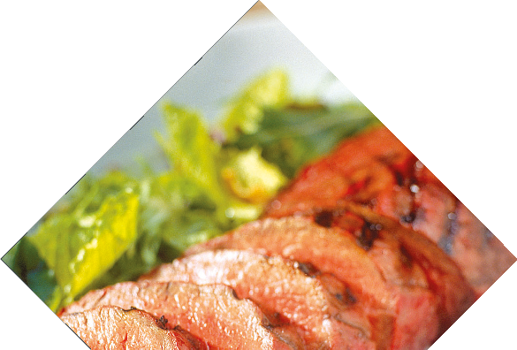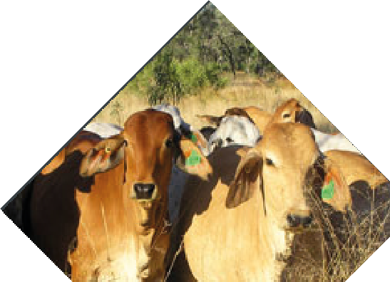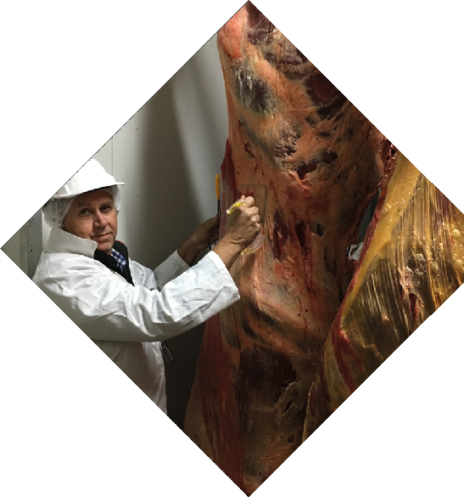Surveillance revealed the presence of bacteria levels that were similar or lower than those detected during
2007 and 2011. This showed enhanced hygiene control measures were effective.

This project demonstrated that Queensland red meat abattoirs continue to maintain a very high standard of hygiene. However, regular carcase hygiene testing and automated monitoring of carcase cooling processes could help strengthen existing controls.

The full report is available via Safe Food’s website.

VERIFICATION & COMPLIANCE

NUMBER OF AUDITS CONDUCTED 3308 | NUMBER OF  CORRECTIVE ACTION REQUESTS 241
NUMBER OF
ASSESSMENTS  4210 | BUSINESSES  SUPPLYING
 | DATA
INDUSTRY MEETINGS
CONDUCTED
10 | 13 18 14 340  TOTAL 385

Strategic priority #2
Work in partnership with all
stakeholders in the food chain to facilitate compliance with food standards

Strategic Priority Success Indicators
Related Regulator Model Practices
To achieve this we are
Effective engagement mechanisms in place between Safe Food and Industry
Be transparent and accountable in actions
Consult and engage meaningfully with stakeholders
Provide appropriate information and
support to assist compliance
Increasing numbers in relation to notifications involving food produced in Queensland, giving early warnings
Ensure regulatory activity is proportionate to risk and minimises unnecessary burden
Provide appropriate information and
support to assist compliance
Maintaining and developing industry pathways to underpin constructive dialogue with industry sectors
Embracing and contributing to the knowledge networks developed by other agencies engaged in food production and regulation Supporting specialist technical workshops and seminars
Assisting small businesses in meeting their food safety training needs through advice, published guidance and contemporary
initiatives

Safe Food works in partnership with key stakeholders in the food business sector to build confidence and trust in the Queensland regulatory system through effective risk communication and dialogue with all concerned.

Safe Food, in collaboration with industry, continues to develop and refine its supply chain food safety baselines. The baselines provide a through-chain systems approach that identifies the most appropriate food safety interventions and verification points based on the recognised production systems and desired behaviours. As of 30 June 2019, Safe Food has developed baselines for red meat, poultry meat, dairy, egg production/processing, oyster growers and pickers and seed sprouts.

As businesses we accredit achieve consistently high rates of compliance, audits of food businesses continue to be replaced or complemented with other compliance methods, such as assessments (see ‘How we verify industry
compliance’ on page 8). The number of businesses audited has decreased in line with an increase in the number of activities being assessed through Safe Food’s CAS.

The number of businesses providing data remotely to Safe Food continues to increase, demonstrating efficiency, transparency and greater confidence in the food supply system. After successfully trialing this approach in the dairy industry followed by the poultry industry, the opportunity was extended to businesses under the food safety schemes for meat, seafood and eggs.

We have a range of tools for facilitating and enforcing compliance that are graduated and proportionate to the severity of the non-conformance with food standards. A total of 241 Corrective Action Requests (CARs), 15 compliance notices, 6 Penalty Infringement Notices (PINs) and zero prosecutions were recorded in 2018-19 (refer to page 20).

Safe Food continued to engage with industry sectors through regular industry meetings, participation in conferences and workshops, and arranging individual meetings with businesses, industry representatives and peak bodies to reinforce the message of responsibility, discuss emerging and topical issues and to encourage improvement in standards for food safety.

We also participated and contributed to a range of national forums on food regulation, including meetings of committees and other groups, such as the Food Regulation Standing Committee, the Australian Meat Regulators Group and the Dairy Industry Export Consultative Committee. In addition, Safe Food continued to provide secretariat support for Queensland’s Food Regulation Senior Officers’ Working Group.

Case study 3
Working in partnership with Australia’s dairy industry

In 2018-19, Safe Food partnered with Dairy Australia to deliver two online learning courses for dairy manufacturers across Australia. Funded by the Federal Government’s Package Assisting Small Exporters (PASE) grant program, these courses were designed to assist dairy manufacturers understand their food safety responsibilities within the domestic market, with a view to becoming ‘trade ready’.

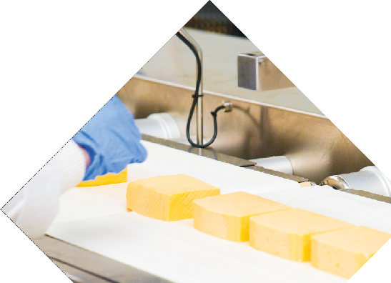The first course was a practical guide to the food recall process in Australia, including effective communication
and business continuity planning strategies to help inform a food recall plan that meets statutory requirements.

The second course provided a practical guide to microbiological testing in dairy manufacturing, including what microbiological hazards affect the dairy industry and how microbiological testing fits within a broader verification program.

Both courses are available via Dairy Australia’s new Manufacturing Resource Centre free of charge.

Case study 4
Working in collaboration with the oyster industry

Oysters are filter feeding, bi-valve molluscs with little control over what they consume. As such, bio- accumulation of bacteria, metals, chemicals, marine bio-toxins or viruses can occur in their tissues. As oysters are often consumed raw, they pose a higher risk of causing foodborne illness than other foods. In 2010, Safe Food established the Seafood Scheme which requires oyster producers and processors to meet requirements that control inputs and harvest areas under Standard 4.2.1 of the Food Standards Code.

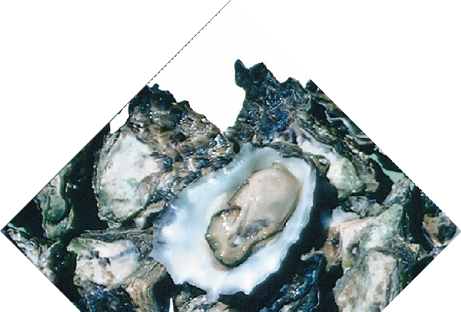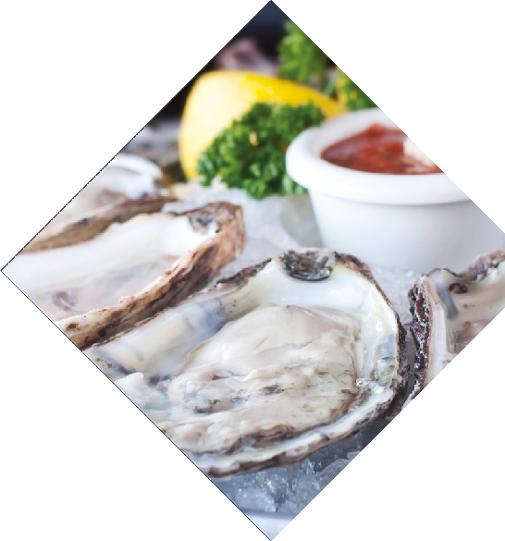With total edible oyster production increasing by 44.3% in 2017-181, Safe Food has re-assessed its regulatory activity to ensure public health is maintained. In 2018-19, Safe Food worked in collaboration with the Queensland Oyster Growers Association, which represents oyster producers and processors in the Moreton Bay area, and individual oyster pickers harvesting from naturally occurring ground banks in the Mackay and Yeppoon regions, to determine and agree upon a compliance model
for the industry.

Each holder of accreditation provided microbiological test results for their finished product to Safe Food and undertook a traceability exercise. Results demonstrated that there were sufficient controls in place to manage food safety risks. Overall, this co-created compliance model has provided a pathway to verifying compliance with the Standard by focusing on key food safety steps and minimising unnecessary regulatory burden on businesses.

1Ross Lobegeiger report to farmers: Aquaculture production summary for Queensland 2017–18

Case study 5
Facilitating compliance in the seed sprout industry

In 2013, the Production and Processing Standard for Seed Sprouts was introduced into the Food Standards Code. The Standard included regulatory requirements for seed sprout processors to control hazards through the management of seed receipt, inputs, seed sprout decontamination procedures and responsibilities relating to supply and sale. Following the incorporation of these requirements into the Food Production (Safety) Regulation 2014, Safe Food began working in partnership with sprout processors to develop a through-
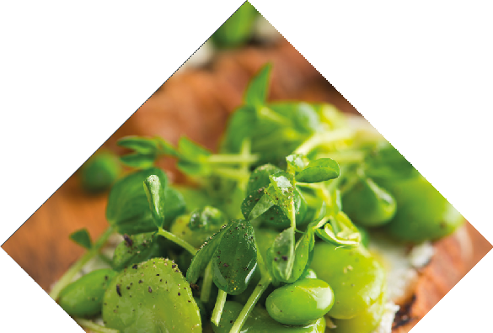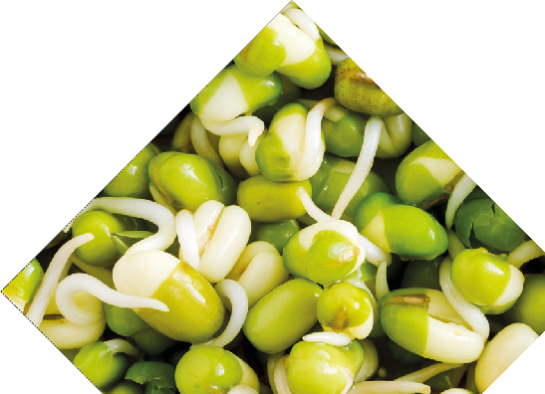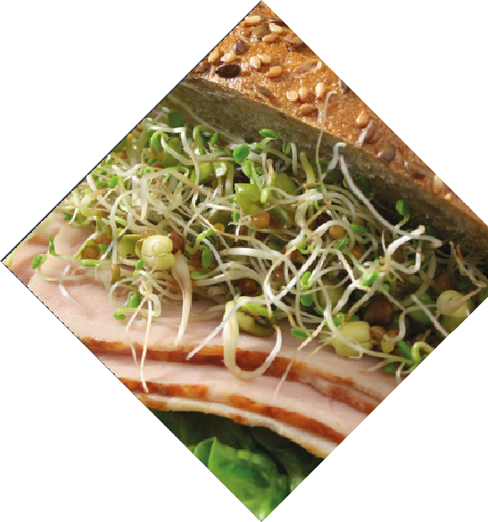chain concept to form the basis for monitoring and verifying the control of food safety risks.

In 2017, Safe Food commenced on-site compliance assessments of accredited sprout processors to determine their awareness of, provision for and commitment to the management of these food safety risks. Information gathered during these assessments was used to identify areas for improvement
to further strengthen the food safety system. In 2018, Safe Food facilitated the first seed sprout processor industry meeting to discuss these findings and provide information and support to facilitate compliance.

In 2019, a more detailed analysis was conducted on decontamination interventions and assessing the management of key verification points in the process. Safe Food provided supplementary information to further assist compliance. During these visits, it was also noted that there was considerable improvement
in the awareness of food safety and overall implementation of controls within each business since the Standard was implemented.

NOTIFICATIONS & RESPONSE

NOTIFICATIONS & COMPLAINTS BREAKDOWN  100  94  89  69  65  15  47  19 16  5 | NOTIFICATIONS & COMPLAINTS 504  RECEIVED
6 PENTALTY
INFRINGEMENT
NOTICES ISSUED
COMPLIANCE
NOTICES
ISSUED

RECALLS
RELATING TO
5
ACCREDITED
BUSINESSES

Strategic priority #3
Ensure that Safe Food is responsive, efficient, effective and delivers value for money

Strategic Priority Success Indicators

Deliver minimal, cost effective regulation that leaves a small imprint on day to day business operations

Information systems that make the benefits of regulation apparent

Efficiencies that make existing resources go further

Related Regulator Model Practices
Ensure regulatory activity is proportionate to risk and minimises unnecessary burden
Commit to continuous improvement Consult and engage meaningfully with stakeholders

Provide appropriate information and support to assist compliance
Be transparent and accountable in actions

Ensure regulatory activity is proportionate to risk and minimises unnecessary burden
Commit to continuous improvement Provide appropriate information and support to assist compliance

To achieve this we are

Maintaining and upgrading IT systems and infrastructure so that they provide the best value for money
Establishing appropriate disaster recovery and business continuity facilities Being open and transparent in all communications
Reviewing and enhancing existing performance management systems and continue to provide for the on- going training and continued professional development of staff

Safe Food recognises the dynamic commercial and consumer environments in which accredited businesses operate and provides businesses with increasingly flexible ways for demonstrating compliance with food safety requirements.

Five recalls relating to food produced by accredited businesses were actioned. Each recall required an investigation by both the business and Safe Food to determine the root cause of the recall and to ensure appropriate steps were taken to address the cause.

Safe Food was notified of 504 alleged food safety issues. This included notifications from accredited food businesses, who are required to notify Safe Food when they believe the acceptability of product may have been compromised with potential to present a food safety concern. Through this proactive approach Safe Food can ensure that any risks are managed and addressed by the relevant business. The majority of notifications comprised of microbiological detections (18%), hygiene issues (20%) and unaccredited activities (19%).

Safe Food worked closely with the Queensland egg industry and Biosecurity Queensland to reinforce interventions on farm to reduce the risk of commercial layer flocks becoming infected with Salmonella enteritidis, which has the potential to threaten the prosperity of egg production in Queensland.

Safe Food also continued to ensure strong governance arrangements, with the agency reviewing and publishing a range of policies and processes, including:

- Internal and administrative complaints,

- Public interest disclosure policy and plan,

- Business continuity plan, and

- Policy that addresses section 48A of the Crime and Corruption Act 2001.

Case study 6
Improving food safety through innovation and collaboration

In 2018-19, Safe Food accredited businesses supplied over 120 million dozen eggs into the supply chain. A well-coordinated, through-chain approach to food safety is an important ingredient to maintaining confidence in the safety of Queensland eggs. Since 2015, in collaboration with industry, Safe Food has led a coordinated and innovated effort to ensure Queensland eggs meet food safety requirements.

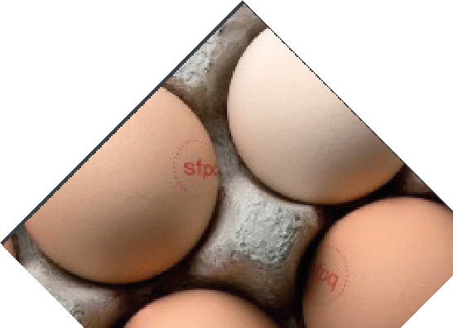Safe Food’s approach is to promote the adoption of industry best practice and information sharing initiatives,
underpinned by strong industry engagement and baseline mapping. This mapping identifies key steps during production and processing where food safety performance can be benchmarked, to help drive improvement and achieve sustained compliance. This approach promotes greater collaboration
with industry and helps inform decision-making when responding to food safety notifications and
incidents.

Queensland has experienced a remarkable decrease in cases of Salmonella typhimurium
infection notifications in the last five years (from 2076 cases in 2015 to 425 in 2018). Salmonella typhimurium is associated with the consumption of contaminated raw egg products. As an agency that has embedded continuous improvements within its culture, Safe Food will continue to enhance data collection and analysis to gain
a deeper understanding of the behaviours that influence food safety, inform
decision making and respond to challenges.

Case Study 7
Assisting start-ups while managing risk

In January 2019, Safe Food implemented a process of issuing temporary accreditations to new applicants undertaking medium-risk or high-risk food production activities, as defined under the Food Production (Safety) Act 2000. Under a temporary accreditation, businesses must have their food production system approved by Safe Food before they can supply foods that pose a higher risk to consumers, such as ready-to-eat meats, oysters and dairy products.

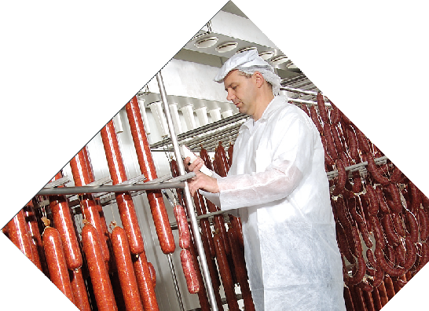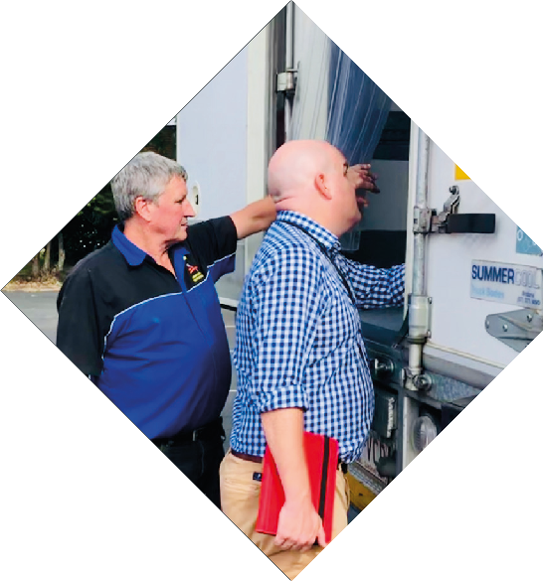Temporary accreditations are issued for a period of up to two months before a business can be considered for an open accreditation. During this time, the business provides additional technical information to Safe Food to demonstrate their nominated food safety controls are effective in maintaining compliance with
food safety requirements. The temporary accreditation process enables start-up businesses to get up and running quickly and commence trade of low-risk products while undergoing a verification procedure for higher risk foods.

Safe Food Board

Safe Food is directly accountable to an expertise-based Board that reports to the Minister for Agricultural Industry Development and Fisheries.

The Safe Food Board consists of a Chair and four other Directors and provides strategic direction to the agency.

The Board ensures the effectiveness of planning processes and governance practices and the integrity of reporting systems. It is also responsible for ensuring the organisation operates according to sound financial management principles and practices.

The Board maintains an overview of the administration and policies of the organisation, but has no direct management responsibility, nor does it play a regulatory role. The Chief Executive Officer (CEO) is responsible for the day-to-day management of the organisation.

The Board members for the reporting period are:

  - Chair Kathryn Adams (2016 to August 2018)

  - Chair Debra-Lee (Debbie) Best (from May 2019)

  - Peter White

  - Elizabeth (Libby) Homer

  - Malcolm Letts (representative of the Chief Executive of Department of Agriculture and Fisheries)

  - Sophie Dwyer (representative of the Chief Executive of Queensland Health)

The Chair and Directors are appointed by the Governor in Council upon the recommendation of the Minister. All Board Directors are independent, non-executive Directors, appointed on a part-time basis for up to three years. Directors are appointed on the basis of having each demonstrated substantial achievement in their chosen field.

Board meetings
The Board meets quarterly and requires a quorum of Directors eligible to vote (i.e. at least three members). In order to meet operational needs, the Board may convene special meetings or use electronic methods to agree or respond to specific issues. The Board met four times during 2018-19.

Board director | Board meetings attended | Strategic planning workshop attended
Debra-Lee Best (Chair) | 0 | 0
Kathryn Adams (Chair) | 1 | 0
Peter White | 4 | 1
Elizabeth Homer | 4 | 1
Malcolm Letts | 3 | 1
Sophie Dwyer | 4 | 1

Debra-Lee Best, Chair
Debra-Lee (Debbie) Best was appointed as Chair in 2019. Debbie has more than 36 years of executive leadership experience in the Queensland State Government in areas ranging from education, indigenous policy and programs, multicultural affairs, environmental management, community engagement and natural resource
management. Debbie currently serves as Chair of the Queensland Heritage Council, Chair of the Audit and Risk Committee for the Department of Natural Resources Mines and Energy, and is an independent member of the Audit Committee for the Electoral Commission of Queensland.

Debbie is a member of the State Awards Committee for the Duke of Edinburgh’s International Award and has previously held positions as Director-General, Deputy Director-General, Assistant Director-General, Regional Director and secondary Principal. She is also a former Board member and Trustee of QSuper and is a graduate of the Australian Institute of Company Directors.

Kathryn Adams, Chair (2016 – 2018)
Kathryn served on the Safe Food Board during the periods of 2007 to 2013 and 2016 to August 2018. Kathryn’s qualifications include a Master of Business, Master of Environmental Studies, Bachelor of Science, Agriculture (Hons), Diploma of Law, Graduate Diploma of Legal Practice and a Graduate Diploma of Administration.
She is a fellow of the Australian Institute of Company Directors and is a member of the Queensland and New South Wales Law Society and the Australian Institute of Agricultural Science and Technology. Kathryn has extensive experience in the Agricultural industry within Queensland and New South Wales in addition to her experience in legal practice.

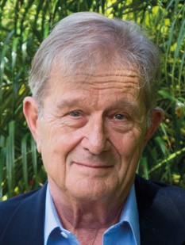 | Peter White  Peter White was appointed as Director in 2013. Peter has extensive experience in meat business operations in both the domestic and export markets. Peter was General Manager for Marketing for over 20 years at Australia Meat Holdings and  was Joint Chief Executive Officer and Director from 1998. Prior to that Peter worked for over 15 years in senior management roles at Thomas Borthwick & Sons in both Australia and London.

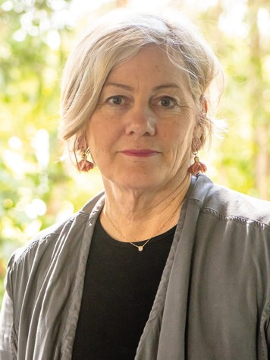 | Elizabeth Homer  Elizabeth (Libby) Homer was appointed as Director in 2016. Libby has a strong background in primary production and manages the operations of a grazing property in Central Queensland. Her qualifications include a Bachelor of Science in Medical Microbiology from the University of Queensland. She had been extensively involved in the North Australian Beef Industry, predominantly in the Research and Development Sector. She is a graduate of the Australian Institute of Company Directors and has been named in the Top 100 Women in Agribusiness.

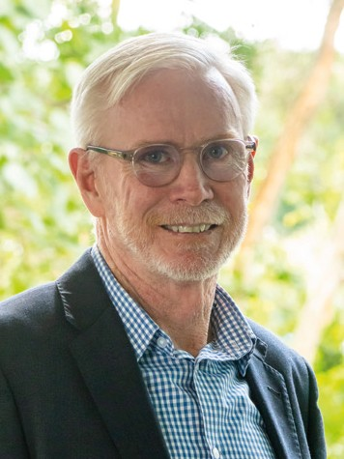 | Malcolm Letts  Malcolm Letts was appointed as a Director in 2015. Malcolm has held the role of Deputy Director-General and Chief Biosecurity Officer since October 2017. Prior to this, Malcolm was the Deputy Director-General, Agriculture. He leads the State’s efforts in the management of animals and plant pests and diseases, invasive species, animal welfare and agricultural chemical use. He has extensive experience in managing policy around agricultural industry development, food safety and traceability, and in rural and industry development, trade, investment attraction and agricultural policy made for a smooth transition into biosecurity. Malcolm is the Qld Government representative on the National Biosecurity Committee and chaired a number of state and national biosecurity committees, including the Intergovernmental Agreement on Biosecurity Research and Innovation Working Group.

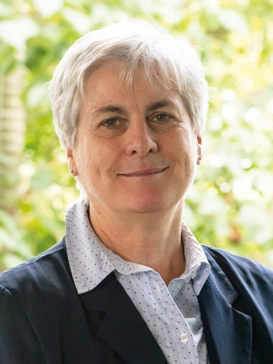 | Sophie Dwyer  Sophie Dwyer was appointed as a Director in 2010. Sophie Dwyer is the Executive Director of the Health Protection Branch in Queensland Health. The Branch is responsible for health risk assessment and regulation in environmental health (including food safety, poisons, radiation safety and water and general risks to public health). Her career has covered a wide range of public health responsibilities,  including the management of local public health units and Queensland Health’s health promotion programs and was awarded the Public Service Medal in 2008. She has a Bachelor of Environmental Science (Hons), a Bachelor of Social Work, a Graduate Diploma in Management and a Masters of Public Health. She is a graduate of the Australia Institute of Company Directors.

Organisational arrangements

Strategic workforce planning and performance
During 2018-19, Safe Food had 34 full-time equivalent positions located in Brisbane. No redundancy, early retirement or retrenchment packages were paid during this period.

Safe Food has in place workforce planning arrangements and strategies to attract and retain skilled and capable workers with a diversity of skills and experiences, as well as a comprehensive employee management framework.

Safe Food actively promotes flexible working arrangements and recognises work-life blend to benefit productivity and commitment to the organisation. Safe Food has in place flexible working hours and leave arrangements, provision of parenting facilities, working from home, telecommuting and part-time opportunities.

The agency is committed to building a responsive and agile workforce that creates new opportunities through its people and prides itself on being an employer of choice.

Safe Food is also committed to building a risk intelligent culture, which means that everyone understands the agency’s approach to risk, takes personal responsibility to manage risk in everything they do, and encourages others to follow their example. Safe Food does this by cultivating awareness of how our collective behaviour influences and impacts on the food safety agenda and strategic vision.

Safe Food’s strategic workforce plan is developed in line with the Queensland Government 10 year human capital outlook.

STAFF SNAPSHOT

TIME AT SAFE FOOD  41.2 %  58.8 %  Over 10 years  Under 10 years | 34  TOTAL STAFF
7 AVERAGE  YEARS OF  SERVICE | GENDER BREAKDOWN  15 19

Safe Food’s values
  - Diligence, professionalism and integrity in all areas of our work,

  - Effectively and efficiently dealing with our clients and the community,

  - Fairness and equity,

  - Respect for the law and for other people, and

  - Avoid conflicts of interest.

Executive management and leadership
The CEO reports to Safe Food’s Board of Directors and the Minister for Agricultural Industry Development and Fisheries. The CEO is responsible for leading and managing the affairs of Safe Food including strategically positioning the agency to achieve organisational and financials goals and implementing Board policy.

The Leadership Group, which consists of the CEO, directors and managers, is responsible for monitoring the performance of the business, ensuring statutory requirements are met and overseeing the development of risk management strategies for Safe Food.

ORGANISATIONAL STRUCTURE
MINISTER FOR AGRICULTURAL INDUSTRY DEVELOPMENT AND FISHERIES

SAFE FOOD BOARD

COMPLIANCE & VERIFICATION

Systems verification (audits & assessments) Monitoring baselines
Enforcement
Managing accreditations Incident response Surveillance intelligence
Managing third party audit systems Notification actions
Service level agreements Risk assessments
POLICY & ENGAGEMENT
Policy, strategy & legislation maintenance Interagency collaboration
Communication & marketing Stakeholder education & collaboration Event coordination
Corporate reporting Reporting & briefings
National systems development Scientific analysis & evaluation

LEADERSHIP

CEO

TEAM

CORPORATE SERVICES
Accreditation administration Financial resource management Human resource management Processional development Travel management
Governance & board management Organisational risk management Contract management Correspondence & administration
INFORMATION & TECHNOLOGY
Data management
Cyber security management Digital maintenance
Software licensing management Software development Internet/intranet management
E-learning platform management Record management
Digital asset management Privacy & right to information

Corporate governance practices

Safe Food achieves its corporate objectives through strong corporate governance, risk management strategies, planning and continuous business improvement. Our corporate priorities are aligned with our corporate policies and processes. Effective corporate planning across the agency ensures statutory obligations are met.

We continually review our operational plans to strengthen our corporate planning processes and to improve the way we monitor, evaluate and deliver our performance obligations.

Safe Food’s ability to make quality decisions and act upon them relies on the provision of sound information, good
judgement, ethical behaviour and effective relationships.

The application of effective compliance, performance and risk management processes and mechanisms develops robust
corporate governance and underpins our approach.

Our framework is based on the ethics principles outlined in the Public Sector Ethics Act 1994 and the governance concepts in the Financial and Performance Management Standard 2009.

There are a number of internal accountability mechanisms that enable us to manage risk, seize opportunities, and monitor, evaluate and report on our performance as shown in the table below.

Internal accountability mechanisms

Plan | Objectives | Outcome | Document
Statement of Strategy | Prioritises the strategic direction over the long term | Summary of performance against priorities | Annual report
Business Plan | Identifies specific corporate priorities for the year | Provides information to the Board and leadership group against milestones | Quarterly reports
Operational Plans | Supports the delivery of corporate priorities | Provides leadership with information on progress towards milestones | Weekly meeting minutes
Professional Development Plans | Supports staff in contributing to strategic priorities | Provides feedback to staff | Annual reviews

Corporate planning and performance management

Safe Food seeks to improve the way in which we manage our corporate planning and performance management
activities to ensure the integrity of the data and to be innovative and efficient in how we use that data.

Internal audit charter
As part of the internal audit process, Safe Food engages an external provider to examine its systems. The provider also reviews preparation of the annual financial statements and follows up on the prior year’s outstanding issues (if any), ensuring the recommendations of the prior audit reports are being implemented.

The internal audit plan is prepared in conjunction with the Leadership Group and approved by the Safe Food Board annually. The internal audit function has due regard to Queensland Treasury’s Audit Committee Guidelines.

Audit and risk committee
Safe Food’s Audit and Risk Committee was established in April 2018, acting as sub-committee to the Board. The role of the Committee is to assist the Board in regard to business risk management, compliance and monitoring and related
legal, financial and regulatory requirements. The Committee has observed its Terms of Reference (Charter) and had due
regard to the Audit Committee Guidelines.

The Committee makes recommendations regarding the level of risk that the agency is prepared to accept in pursuit of its objectives. This informs Safe Food’s risk appetite statement, risk principles and risk tolerances, and ensures that Safe Food establishes and maintains an appropriate and effective risk management framework.

The Committee members and remuneration are listed below:

Committee position | Name | Remuneration
Chair | Elizabeth Homer | $2,600
Member (Board) | Peter White | Nil
Member (external independent) | Helen Pennisi | $2,250
Member (CEO) | Jim Dodds | Nil

Public sector ethics

Safe Food requires all employees to maintain high standards of ethical behaviour in the execution of their duties. The Leadership Group provide direction and guidance to staff in shaping an ethical workplace and helping staff to make better decisions while striving to achieve our objectives.

The principles set out in the Public Sector Ethics Act 1994 form the basis of our Code of Conduct and our integrity
framework. The Safe Food Code of Conduct requires staff to:

  - Act with integrity and impartiality, ensuring high standards of workplace behaviour and personal conduct,

  - Promote the public good through excellence in customer service, community engagement and working with other agencies,

  - Commit to the system of government through conscientious service to Safe Food and government, and

  - Act with accountability and transparency to support high standards of administration.

All new officers participate in Code of Conduct training as part of their induction program.

Code of Conduct
Safe Food’s Code of Conduct reflects the diversity and uniqueness of the agency’s business. It is a practical guide to ethical decision making and responsible behaviour that incorporates the principles outlined in the Public Sector Ethics Act 1994, namely:

  - Integrity and impartiality,

  - Promoting the public good,

  - Commitment to the system of government, and

  - Accountability and transparency.

Safe Food’s Code of Conduct and all policies and procedures are promoted regularly and are available to staff on the
Safe Food intranet. All employees must comply with the Code of Conduct.

Workplace health and safety

The health, safety and wellbeing of all employees, contractors and site visitors is a priority for Safe Food.

The Workplace Health and Safety committee has representation from across the organisation and meets monthly to review progress, identify risks and put forward recommendations to improve workplace conditions.

In particular, the committee has reviewed risks and hazards associated with work in-field and has progressed work to address these risks, including fatigue management, working in isolation, environmental hazards and exposure to zoonotic diseases.

New employees receive workplace health and safety training as part of their induction, to ensure they can perform their duties in accordance with the Work Health and Safety Act 2011 and associated Safe Food policies.

Ongoing training is also in place to ensure all employees can perform their work safely and without risk to their own, or others, health and safety. This includes:

- Induction refresher training,

- Fire safety training,

- First aid training including CPR refresher,

- Mental health first aid training, and

- Driver safety training for staff that work in-field.

As well as workplace safety initiatives and training, the agency also offers staff access to two Employee Assistance Providers and supports flexible work arrangements for a number of employees. This aligns with the ‘keep Queenslanders healthy’ priority of the Our Future State: Advancing Queensland’s Priorities.

Additional information

Right to information
Safe Food is committed to providing the community with open and transparent access to information about our
services and activities while protecting the privacy of clients and staff.

Safe Food is committed to releasing as much information as possible and provides access to information in accordance with the legislation and its Open Data strategy. Our website also contains a wide range of information, most of which is downloadable.

Although we provide the community with a significant amount of easily accessible information, interested parties are also able to make an application under the Right to Information Act 2009 (RTI Act) should they seek to obtain access to information that is not their personal information.

The Information Privacy Act 2009 (IP Act) provides people with the means to access their personal information to ensure it is accurate, complete, up-to-date and not misleading.

The IP Act recognises the importance of protecting the personal information of individuals, gives individuals control over the use and disclosure of their personal information, creates the right for individuals to access and amend their own personal information, and stipulates how agencies must handle personal information.

Concerns or queries relating to the collection, access, storage, use or disclosure of personal information, can be obtained by:

  - Calling Safe Food on: (07) 3253 9800

  - Free Call: 1800 300 815 (QLD only)

  - E-mailing: privacy@safefood.qld.gov.au

Right to information and information privacy applications
Safe Food received one privacy application in the 2018-19 period and no RTI applications.

Making an application
An application for access to documents under either the RTI Act or IP Act may be made via:

  - https://www.smartservice.qld.gov.au/services/information-requests/home action

  - Calling Safe Food on (07) 3253 9800

  - Free Call: 1800 300 815 (QLD only)

  - E-mailing: privacy@safefood.qld.gov.au

Applicants must provide proof of identity when applying for access to documents concerning their personal information.

If applying for access to information that is not your personal information, an initial application fee must be paid before the application will be processed. Processing and photocopying charges may apply.

If applying for access to information that is your personal information, an application fee is not payable, but access charges may apply.

Board remuneration
For 2018–19, data for Board remuneration will be published through the Safe Food website (www.safefood.qld.gov.au).

Record keeping
Record keeping information systems and record keeping are an important part of Safe Food’s management of the Food Production (Safety) Act 2000. We continue to develop strategies and activities supporting the implementation of the Queensland Government Records Governance Policy issued under the Public Records Act 2002. Safe Food’s
accreditation and audit management system (HENRI) provides real-time record management capabilities that support
the agencies day-to-day operational, compliance, verification and enforcement activities.

Safe Food maintains a mix of digital and paper-based records to support operational, governance and strategic outcomes. The agency has implemented a records management plan designed to support and advance our recordkeeping maturity and Safe Food’s initiatives towards the Queensland Government’s Digital 1st strategy.

Open data
For 2018-19, consultancies and overseas travel will be published through the Queensland Government Open Data website (www.qld.gov.au/data) where applicable.

An internal open data policy team performs an audit to ensure datasets have been published correctly.

Cybersecurity
The agency recognises the importance of strong cybersecurity controls.

In the 2018-19 period, the agency reviewed its cybersecurity systems to ensure compliance with the Queensland Government Chief Information Office Information Standard 18:2018 (Information Security Policy) including implementation of an Information Security Management System based on ISO:27001.

The Safe Food Information Security Plan ensures that the agency is focused on continuous review and improvement of these controls.

Our financial position

Safe Food Production Queensland
Statement of Comprehensive Income for the year ended 30 June 2019

Notes 2019 2018
$ $

Income
Revenue
User charges & fees B1-1
4,663,817
1,900,000
146,376
46,182
10,247
6,766,622

3,693,699
2,336,029
829
263,525
37,358
6,331,441
435,181
435,181

Grants & Contributions B1-2
Interest
Other revenue
Gain on disposal of property, plant and equipment
Total income

Expenses

Employee expenses B2-1
Supplies and services B2-2
Finance/ Borrowing Costs
Depreciation and amortisation B2-3
Other expenses B2-4
Total expenses

Operating surplus/ (deficit)

Total comprehensive income for the year

The accompanying notes form part of these financial statements.

4,831,174
1,900,000
129,634
142,113
-

7,002,921

4,113,984
2,441,497
811
244,615
33,758

6,834,664

168,257

168,257

Safe Food Production Queensland
Statement of Financial Position as at 30 June 2019

Notes
2019 2018
$ $

ASSETS

Current assets
Cash and cash equivalents | C1 | 7,539,119 | 6,898,759
Receivables | C2 | 320,407 | 480,312
Other assets | C3 | 171,292 | 196,034
Total current assets |  | 8,030,818 | 7,575,105
Non-current assets  Intangible assets | C5-1 | 256,000 | 473,049
Property, plant and equipment | C4-1 | 143,877 | 75,218
Total non-current assets |  | 399,877 | 548,267
TOTAL ASSETS |  | 8,430,695 | 8,123,372
LIABILITIES
Current liabilities  Payables | C6 | 624,385 | 536,188
Employee benefits provisions | C7 | 177,773 | 352,700
Provisions | C8 | 39,597 | 38,766
Other liabilities | C9 | 1,769,705 | 1,692,296
Total current liabilities |  | 2,611,460 | 2,619,951
TOTAL LIABILITIES |  | 2,611,460 | 2,619,951
NET ASSETS |  | 5,819,235 | 5,503,421
EQUITY  Accumulated surplus |  | 5,819,235 | 5,503,421
TOTAL EQUITY |  | 5,819,235 | 5,503,421

The accompanying notes form part of these financial statements.

Safe Food Production Queensland
Statement of Changes in Equity for the year ended 30 June 2019

Notes
2019  $ |  |  | 2018  $
Accumulated Surplus
Balance 1 July |  | 5,503,421 | 5,335,164
Prior Year Adjustment | E5 | (119,367) | -
Total comprehensive income for the year |  | 435,181 | 168,257
Balance 30 June |  | 5,819,235 | 5,503,421

The accompanying notes form part of these financial statements.

Safe Food Production Queensland
Statement of Cash Flows for the year ended 30 June 2019

Notes
2019 2018
$ $
4,901,347
1,900,000
266,865
111,093
146,376
46,182
7,371,864
(3,873,324)
(1,638,903)
(248,255)
(129,869)
(736,267)
(6,626,618)
745,246
10,249

(115,135)
-
(104,886)
640,360
6,898,759
7,539,119

Cash Flows from Operating Activities

Inflows
User charges |  |  | 4,574,086
Government contributions |  |  | 1,900,000
GST input tax credits from ATO |  |  | 307,611
GST collected from customers |  |  | 134,281
Interest |  |  | 129,634
Other |  |  | 142,113
 |  |  | 7,187,725
Outflows  Employee expenses |  |  | (3,974,427)
Supplies and services |  |  | (1,692,393)
GST paid to suppliers |  |  | (273,024)
GST remitted to the ATO |  |  | (110,169)
Other |  |  | (734,008)
 |  |  | (6,784,021)
Net cash provided by operating activities | CF-1 |  | 403,704
Cash Flows from Investing Activities
Inflows  Proceeds from sale of property, plant and equipment |  |  | -
Outflows  Payments for property, plant and equipment |  |  | (19,985)
Payments for intangibles |  |  | (264,420)
Net cash used in investing activities |  |  | (284,405)
Net increase in cash and cash equivalents held |  |  | 119,299
Cash at beginning of financial year |  |  | 6,779,460
Cash and cash equivalents at end of financial year | C1 |  | 6,898,759
The accompanying notes form part of these financial statements.

Safe Food Production Queensland
Notes to Statement of Cash Flows for the year ended 30 June 2019

Notes
2019 2018
$ $

CF-1 Reconciliation of Operating Results to Net Cash Provided by Operating Activities

Operating Surplus |  | 435,181 | 168,257
Non-Cash items included in operating result:  Depreciation and amortisation expense |  | 263,525 | 244,615
Gain on sale of plant & equipment |  | (10,247) | -
Other non-cash items: Prior period error | E5 | (119,367)
Change in assets and liabilities  (Increase) / decrease in receivables |  | 160,122 | (182,623)
(Increase) / decrease in other assets |  | 24,742 | 55,350
Increase / (decrease) in payables |  | (62,233) | 213,772
Increase / (decrease) in provisions |  | (23,885) | (21,202)
Increase / (decrease) in other liabilities |  | 77,408 | (74,465)
Net cash from operating activities |  | 745,246 | 403,704

Safe Food Production Queensland
Notes to the Financial Statement, for the year ended 30 June 2019
SECTION 1
ABOUT THE AGENCY AND THIS FINANCIAL REPORT
A1 BASIS OF FINANCIAL STATEMENT PREPARATION

A1-1 GENERAL INFORMATION
Safe Food Production Queensland was established as a Statutory Body under the Food Production (Safety) Act 2000 (FPS Act).

The head office and principal place of business of Safe Food Production Queensland is 138 Juliette Street, Greenslopes, Queensland 4120.
A1-2 COMPLIANCE WITH PRESCRIBED REQUIREMENTS
Safe Food Production Queensland has prepared these financial statements in compliance with section 43 of the Financial and Performance Management Standard 2009. The financial statements comply with Queensland Treasury's Minimum Reporting Requirements for reporting periods beginning on or after 1 July 2018.

Safe Food Production Queensland is a not-for-profit entity and these general purpose financial statements are prepared on an accrual basis (except for the Statement of Cash Flow which is prepared on a cash basis) in accordance with Australian Accounting Standards and Interpretations applicable to not-for-profit entities.

New accounting standards applied for the first time in these financial statements are outlined in Note E3 (AASB 9). Future impact of accounting standards not yet effective are outlined in Note D4 (AASB 15) and (AASB 16).

A1-3 PRESENTATION
Currency and Rounding
Amounts included in the financial statements are in Australian dollars and have been rounded to the nearest dollar, unless disclosure of the full amount is specifically required.

Comparatives
Comparative information reflects the audited 2017-18 financial statements except where restated where necessary to be consistent with disclosures in the current report period.

Current/ Non-Current Classification
Assets and liabilities are classified as either 'current' or 'non-current' in the Statement of Financial Position and associated notes.

Assets are classified as 'current' where their carrying amount is expected to be realised within 12 months after the reporting date. Liabilities are classified as 'current' when they are due to be settled within 12 months after the reporting date, or the Agency does not have an unconditional right to defer settlement to beyond 12 months after the reporting date.

All other assets and liabilities are classified as non-current.

A1-4 AUTHORISATION OF FINANCIAL STATEMENT FOR ISSUE
The financial statements are authorised for issue by the Chairperson and Chief Executive Officer at the date of signing the Management Certificate.

A1-5 BASIS OF MEASUREMENT
Historical cost is used as the measurement basis in this financial report.

Historical Cost
Under historical cost, assets are recorded at the amount of cash or cash equivalents paid or the fair value of the consideration given to acquire assets at the time of their acquisition. Liabilities are recorded at the amount of proceeds received in exchange for the obligation or at the amounts of cash or cash equivalents expected to be paid to satisfy the liability in the normal course of business.

A2 OBJECTIVES OF THE AGENCY
The objective of Safe Food Production Queensland is to work in partnership with industry and with its co-regulatory partners Queensland Health, the Department of Agriculture and Fisheries (DAF) and Food Standards Australia and New Zealand (FSANZ) to ensure Queensland's food production systems comply with national food safety standards and deliver safe and suitable food.

B1 REVENUE
SECTION 2
NOTES ABOUT OUR FINANCIAL PERFORMANCE

B1-1 USER CHARGES AND FEES

User charges and fees controlled by Safe Food Production Queensland are recognised as revenues when the revenue has been earned and can be measured reliably with a sufficient degree of certainty. User charges and fees, except for accreditation fees, are recognised in full as revenues when invoices for the related services are issued. Accreditation fees are receipted in full once received, however recognised over the period of the accreditation.

 | 2019  $ | 2018  $
Accreditation fees | 3,493,747 | 3,590,397
Application fees | 95,766 | 135,084
Audit fees | 1,015,807 | 1,070,220
Fee for service income | 58,497 | 35,474
 | 4,663,817 | 4,831,174
B1-2 GRANTS AND CONTRIBUTIONS

Grants, contributions, donations and gifts that are non-reciprocal in nature are recognised as revenue in the year in which Safe Food Production Queensland obtains control over them (control is generally obtained at the time of receipt). If grants are received that are reciprocal in nature, revenue is progressively recognised as it is earned according to the term of the funding arrangements.

 | 2019  $ | 2018  $
Department of Agriculture and Fisheries (DAF)  B2 EXPENSES | 1,900,000 | 1,900,000
B2-1 EMPLOYEE EXPENSES

Accounting Policy - Wages and Salaries
Wages and salaries due but unpaid at reporting date are recognised in the Statement of Financial Position at the current salary rates. As Safe Food Production Queensland expects such liabilities to be wholly settled within 12 months of reporting date, the liabilities are recognised at undiscounted amounts.

Accounting Policy - Sick Leave
Prior history indicates that on average, sick leave taken in each reporting period is less than the entitlement accrued. This is expected to continue in future periods. Accordingly, it is unlikely that existing accumulated entitlements will be used by employees and no liability for unused sick leave entitlements is recognised. As sick leave is non-vesting, an expense is recognised for this leave as it is taken.

Accounting Policy - Annual Leave
Annual leave entitlements are accrued on a pro rata basis in respect of services provided by employees up to balance date, having regard to future rates of pay and on-costs. Annual leave entitlements are provided for at their nominal value.

Accounting Policy - Long Service Leave
Under the Queensland Government's long service leave scheme, a levy is made on Safe Food Production Queensland to cover this cost. Levies are expensed in the period in which they are paid or payable. Amounts paid to employees for long service leave are claimed from the scheme as and when the leave is taken (quarterly in arrears).

No provision for long service leave is recognised in the financial statements, the liability being held on a Whole of Government basis and reported in the financial report prepared pursuant to AASB 1049 Whole of Government and General Government Sector Financial Reporting.

Accounting Policy - Superannuation
Employer superannuation contributions are paid to QSuper, the superannuation scheme for Queensland Government employees, at rates determined by the Treasurer on the advice of the State Actuary. Contributions are expensed in the period in which they are paid or payable. Safe Food Production Queensland's obligation is limited to its contribution to QSuper.

The QSuper scheme has defined benefit and defined contribution categories. The liability for defined benefits is held on a whole-of- government basis and reported in those financial statements pursuant to AASB 1049 Whole of Government and General Government Sector Financial Reporting.

Accounting Policy - Worker's Compensation Premiums
Worker's compensation insurance is a consequence of employing staff but is not counted in an employee's total remuneration package. It is not employee benefits and is recognised separately as employee related expenses.
Key management personnel and remuneration disclosures are detailed in Note E1.

 | 2019  $ |  | 2018  $
Employee Benefits  Wages and salaries | 3,044,529 |  | 3,212,170
Employer superannuation contributions | 378,133 |  | 389,508
Termination benefits | - |  | 218,278
Other | 259,760 |  | 281,158
Employee Related Expenses  Workers' compensation | 11,277 |  | 12,871
Total Employee Expenses | 3,693,699 |  | 4,113,984

34 FTEs at 30 June 2019 (35 FTEs as 30 June 2018). No employees of Safe Food Production Queensland are employed under the
Public Service Act 2008.

B2-2 SUPPLIES AND SERVICES

Accounting Policy - Operating lease rentals
Operating lease payments are representative of the pattern of benefits derived from the leased assets and are expensed in the periods in which they are incurred. Incentives received on entering into operating leases are recognised as liabilities. Lease payments are allocated between rental expense and reduction of the liability.

Disclosure - Operating leases
Operating leases are entered into as means of acquiring access to office accommodation and motor vehicles. Lease term extend over a period of 5 to 10 years. The Agency has no option to purchase the leased item at the conclusion of the lease although the lease provides for a right of renewal at which time the lease terms are renegotiated.

 | 2019  $ | 2018  $
Supplies and Services
Administration Expenses | 132,644 | 140,817
Advertising and Conference Costs | 34,589 | 54,326
Communication Costs | 51,249 | 78,450
Computer Costs | 263,221 | 268,660
Contracting & Professional Services | 720,637 | 819,582
Legal Costs | 154,855 | 36,774
Motor Vehicle Costs | 64,995 | 86,086
Property, Plant and Equipment Costs | 116,989 | 121,195
Travel Costs | 93,940 | 132,289
Other | 4,805 | 3,878
Operating Lease Rentals | 698,105 | 699,439
 | 2,336,029 | 2,441,497

B2-3 DEPRECIATION AND AMORTISATION
 | 2019 |  | 2018
 | $ |  | $
Depreciation  Plant and equipment | 46,476 |  | 24,543
Amortisation  Computer Software | 217,049 |  | 220,072
Total Depreciation and Amortisation | 263,525 |  | 244,615
B2-4 OTHER EXPENSES
 | 2019 |  | 2018
 | $ |  | $
Impairment Losses (trade receivables) | 12,698 |  | 9,133
Auditors’ remuneration  Queensland Audit Office - external audit services* | 17,660 |  | 17,500
Barr Group Pty Ltd - internal audit services | 7,000 |  | 7,125
Total Other Expenses | 37,358 |  | 33,758

*Total audit fees quoted by Queensland Audit Office relating to the 2018-2019 financial statements are $19,426 GST inclusive (2017:
$19,250).

SECTION 3
NOTES ABOUT OUR FINANCIAL POSITION

C1 CASH AND CASH EQUIVALENTS

Accounting Policy - Cash and Cash Equivalents

For the purpose of the Statement of Financial Position and the Statement of Cash Flows, cash assets include all cash and cheques receipted but not banked at 30 June as well as deposits at call with financial institutions.

 | 2019  $ | 2018  $
Cash on hand | 500 | 500
Cash at bank | 3,558,755 | 3,648,460
Deposits at call | 3,979,864 | 3,249,799
 | 7,539,119 | 6,898,759

C2 RECEIVABLES

Accounting Policy - Receivables
Trade debtors are recognised at the amounts due at the time of sale or service delivery i.e. the agreed purchase/ contract price. Settlement of these amounts is required within 30 days from invoice date.

The collectability of receivables is assessed periodically with provision being period in which they are recognised. All known bad debts were written off as at | made for impairment. 30 June 2019. | Bad debts are written off in the
 | 2019 | 2018
 | $ | $
Trade debtors | 326,354 | 401,656
Less: Allowance for impairment loss | (5,913) | (11,109)
 | 320,442 | 390,547
GST receivable | 68,516 | 59,399
GST payable | (73,354) | (64,453)
Net GST receivable (payable) | (4,838) | (5,054)
Other debtors | 2,028 | 2,448
LSL Claims Receivable | 2,775 | 92,371
 | 4,803 | 94,819
Total Receivables | 320,407 | 480,312
C2-1 IMPAIRMENT OF RECEIVABLES

Accounting Policy - Impairment of Receivables
The loss allowance for trade and other debtors reflects lifetime expected credit losses and incorporates reasonable and supportable forward-looking information. Economic changes impacting the Agency's debtors, and relevant industry data form part of the Agency's impairment assessment.

Where the Agency has no reasonable expectation of recovering an amount owed by a debtor, the debt is written-off by directly reducing the receivable against the loss allowance. This occurrence when the debt is over 90 days past due and the Agency has ceased enforcement activity. If the amount of debt written off exceeds the loss allowance, the excess is recognised as an impairment loss.

The amount of impairment losses recognised for receivables is disclosed in Note B2-4.

Disclosure - Credit Risk Exposure of Receivables
The maximum exposure to credit risk at balance date for receivables is the gross carrying amount of those assets. No collateral is held as security and there are no other credit enhancements relating to the Agency's receivables.

The Agency uses a provision matrix to measure the expected credit loss on trade and other debtors. Loss rates are calculated separately for grouping of customers with similar loss patterns. The Agency has determined there are two material groupings for measuring expected credit losses based on the sale of service and the sale of goods reflecting the different customer profiles for these revenue streams.

The calculations reflect historical observed default rates calculated using credit losses experienced on past sale transactions during the last 10 years preceding 30 June 2019 for each group. The historical default rates are then adjusted by reasonable and supportable forward-looking information for expected changes in macroeconomic indicators that affect the future recovery of those receivables. For Safe Food Production Queensland, change in the business activity (for example, ceased trading) is determined to be the most relevant forward-looking indicator for both groups of receivables. Actual credit losses over the 10 years preceding 30 June 2019 have been correlated against changes business activity and based on those results, the historical default rates are adjusted based on expected changes to that indicator.

Disclosure - Individually Impaired Receivables Position (Aged)
Gross | 2019  Allowance for | Carrying
Receivables | Impairment | Amount
$ | $ | $
Overdue
Current 945 (945) -
1 to 30 days overdue 1,625 (1,625) -
31 to 60 days overdue 190 (190) -
61 to 90 days overdue 189 (189) -
> 90 days overdue - -
Known impairment (in process) 2,964 (2,964)

Total Overdue 5,913 (5,913) -

Gross Receivables
2018
Allowance for Impairment

Carrying Amount

$ $ $
Overdue
Less than 30 days - - -
30 to 60 days 6,110 (6,110) -
60 to 90 days 4,444 (4,444) -
Greater than 90 days 555 (555) - Total Overdue 11,109 (11,109) -

Disclosure - Ageing of Past Due but Not Impaired Receivables
 | 2019  $ | 2018  $
Overdue  Less than 30 days | 195,271 | 231,217
30 to 60 days | 118,739 | 114,569
60 to 90 days | 4,575 | 27,900
Greater than 90 days | 1,856 | 16,862
Total Overdue | 320,442 | 390,547

C3 OTHER ASSETS
 | 2019 | 2018
Prepayments | $  171,292 | $  196,034
 | 171,292 | 196,034

C4 PROPERTY, PLANT AND EQUIPMENT AND DEPRECIATION EXPENSE

C4-1 CLOSING BALANCES AND RECONCILIATION OF CARRYING AMOUNT
 | 2019  $ |  | 2018  $
At cost | 286,153 |  | 282,744
Less: accumulated depreciation | (142,276) |  | (207,526)
 | 143,877 |  | 75,218
Represented by movement in carrying amount
Plant and equipment
Carrying amount at start of year | 75,218 |  | 79,776
Additions | 115,135 |  | 19,985
Depreciation | (46,476) |  | (24,543)
Carrying amount at end of year | 143,877 |  | 75,218
C4-2 RECOGNITION AND ACQUISITION

Accounting Policy - Recognition
Basis of capitalisation and recognition thresholds
Items of property, plant and equipment with a cost or other value equal to or in excess of the following thresholds are recognised for financial reporting purposes in the year of acquisition:

Plant and Equipment $5,000

Items with a lesser value are expensed in the year of acquisition.

Expenditure on property, plant and equipment is capitalised where it is probable that the expenditure will produce future service potential for the Agency. Subsequent expenditure is only added to an asset's carrying amount if it increases the service potential or useful life of that asset. Maintenance expenditure that merely restores original service potential (lost through ordinary wear and tear) is expensed.

Accounting Policy - Cost of Acquisition
Historical cost is used for the initial recording of all property, plant and equipment acquisitions. Historical cost is determined as the value given as consideration plus costs incidental to the acquisition, including all other costs incurred in getting the assets ready for use.

C4-3 MEASUREMENT USING HISTORICAL COST

Accounting Policy
Plant and equipment is measured at historical cost in accordance with the Queensland Treasury's Non-Current Asset Policies for the Queensland Public Sector. The carrying amounts for such plant and equipment is not materially different from their fair value.

C4-5 DEPRECIATION EXPENSE

Accounting Policy
Property, plant and equipment is depreciated on a straight-line basis so as to allocate the net cost or revalued amount of each asset, less its estimated residual value, progressively over its estimated useful life to Safe Food Production Queensland.

Key Estimates and Judgements: Straight line depreciation is used as that is consistent with the even consumption of service potential of these assets over their useful life to the agency.

For depreciable assets, residual value is determined to be zero reflecting the estimated amount to be received on disposal at the end of their useful life.

Any expenditure that increases the originally assessed capacity or service potential of an assets is capitalised and the new depreciable amount is depreciated over the remaining useful life of the asset to Safe Food Production Queensland.

Depreciation Rates
For each class of depreciable asset the following depreciation and amortisation rates are used:

Class | Rate %
Plant and Equipment
Computer Hardware | 33.3
Motor Vehicles | 20.0
Other Plant and Equipment | 20.0
Leasehold Improvements | 10.0-13.0

C4-6 IMPAIRMENT

Accounting Policy
Indicators of impairment and determining recoverable amount
All property, plant and equipment assets are assessed for indicators of impairment on an annual basis or, where the asset is measured at fair value, for indicators of a change in fair value/service potential since the last valuation was completed. Where indicators of a material change in fair value or service potential since the last valuation arise, the asset is revalued at the reporting date under AASB 13 Fair Value Measurement. If an indicator of possible impairment exists, the Agency determines the asset’s recoverable amount under AASB 13 Impairment of Assets.

As a not-for-profit entity, certain property, plant and equipment of the department is held for the continuing use of its service capacity and not for the generation of cash flows. Such assets are typically specialised in nature. In accordance with AASB 136, where such assets measured at fair value under AASB 13, that fair value (with no adjustment for disposal costs) is effectively deemed to be the recoverable amount. As a consequence, AASB 136 does not apply to such assets unless they are measured at cost.
For other non-specialised property, plant and equipment measured at fair value, where indicators of impairment exist, the only difference between the asset’s fair value and its fair value less costs of disposal is the incremental costs attributable to the disposal of the asset. Consequently, the fair value of the asset determined under AASB 13 will materially approximate its recoverable amount where the disposal costs attributable to the asset are negligible. After the revaluation requirements of AASB 13 are first applied to these assets, applicable disposal costs are assessed and, in the circumstances where such costs are not negligible, further adjustments to the recoverable amount are made in accordance with AASB 136.
For all other remaining assets measured at cost, and assets within the economic entity held for the generation of cash flows recoverable amount is equal to the higher of the fair value less costs of disposal and the asset’s value in use.

Value in use is equal to the present value of the future cash flows expected to be derived from the asset, or where the department no longer uses an asset and has made a formal decision not to reuse or replace the asset, the value in use is the present value of net disposal proceeds.

Recoverable amount is equal to the higher of the fair value less costs of disposal and the asset’s value in use subject to the following:
Recognising impairment losses

For assets measured at fair value, the impairment loss is treated as a revaluation decrease and offset against the revaluation surplus of the relevant class to the extent available. Where no revaluation surplus is available in respect of the class asset, the loss is expensed in the statement of comprehensive income as a revaluation decrement.

Reversal of impairment losses

Where an impairment loss subsequently reverses, the carrying amount of the asset is increased to the revised estimate of its recoverable amount, but so that the increased carrying amount does not exceed the carrying amount that would have been determined had no impairment loss been recognised for the asset in prior years.

For assets measured at fair value, to the extent the original decrease was expensed through the statement of comprehensive income, the reversal is recognised in income, otherwise the reversal is treated as a revaluation increase for the class of asset through revaluation surplus.

For assets measured at cost, impairment losses are reversed through income.
C5 INTANGIBLES AND AMORTISATION EXPENSE
C5-1 CLOSING BALANCES AND RECONCILIATION OF CARRYING AMOUNT
 | 2019  $ |  | 2018  $
Software Purchased:  At cost | 1,567,277 |  | 1,567,277
Less: Accumulated amortisation | (1,311,277) |  | (1,096,668)
 | 256,000 |  | 470,609
Software Internally Generated:  At cost | 711,492 |  | 711,492
Less: Accumulated amortisation | (711,492) |  | (709,052)
 | - |  | 2,440
Total | 256,000 |  | 473,049
 | 2019  $ |  | 2018  $
Represented by movement in carrying amount
Carrying amount at start of year | 473,049 |  | 428,701
Additions | - |  | 264,420
Amortisation | (217,049) |  | (220,072)
Carrying amount at end of year | 256,000 |  | 473,049
C5-2 RECOGNITION AND MEASUREMENT

Accounting Policy
Intangible assets of Safe Food Production Queensland comprise purchased software and internally developed software.

Intangible assets with a historical cost or other value equal to or greater than $100,000 are recognised in the financial statements. Item with a lesser value are expensed. Any training costs are expensed as incurred.

There is no active market for any of Safe Food Production Queensland's intangible assets. As such, the assets are recognised and carried at historical cost less accumulated amortisation and accumulated impairment losses.

Expenditure on research activities relating to internally-generated intangible assets is recognised as an expense in the period in which it is incurred. Research and development expensed during the period is included in 'supplies and services expense' (refer to Note B2-2).

Costs associated with the internal development of computer software are capitalised and amortised under the amortisation policy below.

No intangible assets have been classified as held for sale or form part of a disposal group held for sale.

C5-3 AMORTISATION EXPENSE

Accounting Policy
All intangible assets of Safe Food Production Queensland have finite useful lives and are amortised on a straight line basis over their estimated useful life to Safe Food Production Queensland. Straight line amortisation is used reflecting the expected consumption of economic benefits on a progressive basis over the intangible's useful life. The residual value of all the agency's intangible assets is zero.

Class Rate %
Computer Software
Software Purchased 33.3
Software Internally Generated 33.3
C5-4 IMPAIRMENT
Accounting Policy
All intangibles assets are assessed for indicators of impairment on an annual basis. If an indicator of possible impairment exists, Safe Food determines the asset's recoverable amount. Any amount by which the asset's carrying amount exceeds the recoverable amount is recorded as impairment loss.
Intangible assets are principally assessed for impairment by reference to the actual and expected continuing use of the asset by Safe Food Production Queensland, including discounting the use of the software. Recoverable amount is determined as the higher of the asset's fair value less costs to sell and depreciated replacement cost.

C6 PAYABLES
Trade creditors are recognised upon receipt of the goods or services ordered and are measured at the nominal amount i.e. agree purchase/ contract price, gross of applicable trade and other discounts. Amounts owing are unsecured and are generally settled on 14 or 30 day terms.

 | 2019  $ |  | 2018  $
Trade creditors | 211,903 |  | 257,476
Other creditors | 412,482 |  | 278,712
 | 624,385 |  | 536,188
C7 EMPLOYEE BENEFITS PROVISIONS

No provision for long service leave is recognised in the agency's financial statements as the liability is held on a whole-of-government basis and reported in those financial statements pursuant to AASB 1049 Whole of Government and General Government Sector Financial Reporting. Accrued separation payment consist of payments relating to employee separations payments due and payable.

 | 2019  $ | 2018  $
Annual leave | 177,773 | 201,657
Accrued Separation Payment | - | 151,043
 | 177,773 | 352,700

C8 PROVISIONS
Provisions are recorded when the Agency has present obligation, either legal or constructive as a result of a past event. They are recognised at the amount expected at reporting date for which the obligation will be settled in a future period. Where the settlement of the obligation is expected after 12 or more months, the obligation is discounted to the present value using an appropriate discount rate. The amounts recognised as provision in relation to the make good provision for leased premise.

Key Estimates and Judgements: The provision has been discounted using a rate that reflects current market assessment and risks specific to the liability.

 | 2019  $ |  | 2018  $
Restoration costs | 39,597 |  | 38,766
 | 39,597 |  | 38,766
C9 OTHER LIABILITIES

Accreditation fees, are recognised in full as revenues when invoices for the related services are issued. Accreditation fees are receipted in full once received, however recognised over the period of the accreditation.

2019 2018
$ $

Unearned revenue - Accreditation & Application Fees 1,769,705 1,692,296

SECTION 4
NOTES ABOUT RISK AND OTHER ACCOUNTING UNCERTAINTIES

D1 FINANCIAL RISK DISCLOSURES

D1-1 FINANCIAL INSTRUMENT CATEGORIES

Financial assets and financial liabilities are recognised in the Statement of Financial Position. Safe Food Production Queensland has categorised the financial assets and financial liabilities held as:

Category | Notes | 2019  $ | 2018  $
Financial Assets  Cash and cash equivalents | C1 | 7,539,119 | 6,898,759
Receivables | C2 | 320,407 | 480,312
Total |  | 7,859,526 | 7,379,072
Financial Liabilities  Payables | C6 | 624,385 | 536,188
D1-2 FINANCIAL RISK MANAGEMENT

Safe Food Production Queensland's activities expose it to a variety of financial risks - interest rate risk, credit risk, liquidity risk and market risk.

Financial risk management is implemented pursuant to Government and Safe Food Production Queensland policy. These policies focus on the unpredictability of financial markets and seek to minimise potential adverse effects on the financial performance of Safe Food Production Queensland.

Safe Food Production Queensland measures risk exposure using a variety of methods as follows -

Risk Exposure | Measurement method
Credit risk | Ageing analysis
Liquidity risk | Cash flow management

D1-3 CREDIT RISK EXPOSURE

Credit risk exposure refers to the situation where Safe Food Production Queensland may incur financial loss as a result of another party to a financial instrument failing to discharge their obligations.

The maximum exposure to credit risk at balance date in relation to each class of recognised financial assets is the gross carrying amount of those assets inclusive of any provision for impairment.

Financial Assets
No collateral is held as security and no credit enhancements relate to financial assets held by Safe Food Production Queensland.

D1-4 LIQUIDITY RISK

Safe Food Production Queensland is exposed to liquidity risk through its trading in the normal course of business. Liquidity risk is managed on an ongoing basis by ensuring funds are readily available for day to day operations. This is achieved by investing available cash funds in the Safe Food Production Queensland bank account or at call deposit accounts.

D2 CONTINGENCIES

A bank guarantee (security deposit) was provided in 2016 for Head Lease arrangement from the Commonwealth Bank. The amount guaranteed is $231,000 (equivalent to 6 months rent).

D3 COMMITMENTS

Lease commitments
At 30 June 2019, Safe Food Production Queensland had the following operating lease commitments inclusive of GST:

 | 2019  $ | 2018  $
Outstanding lease commitments are due for payment as follows:
Not later than 1 year | 656,497 | 658,259
Later than 1 year but not later than 5 years | 2,311,415 | 2,243,942
Later than 5 years | 1,138,404 | 1,825,817
 | 4,106,316 | 4,728,018

Capital expenditure commitments
At 30 June 2019, Safe Food Production Queensland had the following capital expenditure commitments inclusive of GST:

 | 2019  $ |  | 2018  $
Outstanding lease commitments are due for payment as follows: Not later than 1 year | - |  | 275,000
 | - |  | 275,000
D4 EVENTS AFTER THE BALANCE DATE
There have been no known material post balance date events.

D5 FUTURE IMPACT OF ACCOUNTING STANDARDS NOT YET EFFECTIVE

At the date of authorisation of the financial report, the expected impacts of new or amended Australian Accounting Standards issued but with future commencement dates are set out below:

Changes in Accounting Policies - AASB 15 Revenue from Contracts with Customers
The Agency applied AASB 15 Revenue from Contracts with Customers for the first time in 2018-2019.

Deferred - Application Fees

Application Fees are a prescribed fee that fall under the category of a non-refundable upfront fee charged at or near the time of contract inception. Application fees relate to an activity that the Agency must complete before executing the contract. However, that advance fee payment and the completion of the application assessment process does not result in the transfer of a promised good or service (that is, an Accreditation) to the customer.

As part of the application process, an Applicant must pay both the Application and Accreditation Fees, and satisfy the application requirements, before an accreditation is granted. Both fees are paid in advance of the provision of the service, so this revenue cannot be recognised until the future services are provided.

The completion of the contractual obligations for an Application Fee usually results in an Accreditation. Accreditations are granted for a period of up to one calendar year with a common expiry date of 31 December each year. The contractual obligations include monitoring and verification. Safe Food already defers Accreditation Fee revenue recognition over the same time frame. To comply with AASB 15, revenue recognition for Application Fees will now be treated in a similar fashion. Application date is 1 January 2019.

AASB 16 Leases
This standard will first apply to the Agency from its financial statements for 2019-2020. When applied, the standard supersedes AASB 117 Leases, AASB Interpretative 4 Determining whether an Arrangement contains a Lease, AASB Interpretation 115 Operating Leases - Incentives and AASB Interpretation 127 Evaluating the Substance of Transactions Involving the Legal Form of a Lease.

Impact for lessees
Under AASB 16, the majority of operating leases (as defined by the current AASB 117 and shown at Note D2) will be reported on the statement of financial position as right-of-use assets and lease liabilities.

The right-of-use asset will be initially recognised at cost, consisting of the initial amount of the associated lease liability, plus any lease payments made to the lessor at or before the effective date, less any lease incentive received, the initial estimated of restoration costs and any initial direct costs incurred by the lessee. The right-of-use asset will give rise to a depreciation expense.

The lease liability will be initially recognised at an amount equal to the present value of the lease payments during the lease term that are not yet paid. Current operating lease rental payments will no longer be expensed in the statement of comprehensive income. They will be apportioned between a reduction in the recognised lease liability and the implicit finance charge (the effective rate of interest) in the lease. The finance cost will also be recognised as an expense.

AASB 16 allows a 'cumulative approach' rather than full retrospective application to recognising existing operating leases. In accordance will Queensland Treasury's policy, the Agency will apply the 'cumulative approach,' and will not need to restate comparative information. Instead, the cumulative effect of applying the standard is recognised as an adjustment to the opening balance of accumulated surplus (or other component of equity, as appropriate) at the date of initial application.

Outcome of review as lessee

The Agency has completed its review of the impact of adoption of AASB 16 on the statement of financial position and statement of comprehensive income and has identified the following major impacts which are outlined below.

The Agency has quantified the transitional impact on the statement of financial position and statement of comprehensive income of all qualifying lease arrangements that will be recognised on-balance sheet under AASB 16, as follows.

Statement of financial position impact on 1 July 2019:
- $3,073,256 increase in lease liability
- $2,940,351 increase in right-of-use
- $131,101 decrease in opening accumulated surplus

Statement of comprehensive income impact expected for the 2019-2020 financial year, as compared to 2018-2019:
- $558,619 increase in depreciation and amortisation expense
- $ 98,417 increase in interest expense
- $617,028 decrease in supplies and services expense
- The result in a net increase of $40,008 in total expense

E1 KEY MANAGEMENT

Details of Key Management

SECTION 5 OTHER INFORMATION

The following details for key executive management personnel include those positions that had authority and responsibility for planning, directing and controlling the activities of Safe Food Production Queensland during 2018-19.

Position | Position Responsibility
Chief Executive Officer | Responsible for managing the affairs of the Agency and advising the Board performance of  the Agency.
Chief Operating Officer | Responsible for operational management in line with statute administration and managing and  strengthening the sustaining part of the business.

Remuneration Policies
The remuneration and other terms of employment for the key executive management personnel are specified in employment contracts.

Remuneration expenses for key management personnel comprise the following components:

Short term employee expenses which include:
  - salaries, allowances and leave entitlements earned and expensed for the entire year, or for that part of the year during which the employee was a key management person;
  - Non-monetary benefits - consisting of provision of vehicle together with fringe benefits tax applicable to the benefit.

Long term employee expenses include amounts expensed in respect of long service leave entitlements earned.

Post-employment expenses include amounts expensed in respect of employer superannuation obligation.

Termination benefits include payments in lieu of notice on termination and other lump sum separation entitlements (excluding annual and long service leave entitlements) payable on termination of employment or acceptance of an offer of termination of employment.

Key executive management do not receive performance payments.

1 July 2018 - 30 June 2019
The recruitment and handover process of the Chief Executive Officer (CEO) position commenced during 2018/2019 financial year. The official CEO commenced on 4 March 2019.

Position | Short Term Employee  Expenses |  | Long Term Employee Expense | Post Employment Expense | Termination Benefits | Total Expense
 | Monetary Expenses | Non- Monetary Benefits
Chief Executive Officer (to 23/07/18) * Short term expense including leave  entitlement payouts | 121,134 | 3,249 | 312 | 2,089 | - | 126,785
Chief Executive Officer (Acting 24/07/18  to 14/01/19) | 112,190 | - | 2,534 | 12,408 | - | 127,133
Chief Executive Officer (Acting 15/01/19  to 01/03/19) | 35,451 | - | 689 | 3,372 | - | 39,512
Chief Executive Officer (from  04/03/2019) | 73,290 | - | 1,947 | 9,344 | - | 84,581
Chief Operating Officer (to 23/07/18) | 16,126 | - | 323 | 2,056 | - | 18,505
Chief Operating Officer (Acting from 05/11/18 to 14/01/2019) | 36,461 | - | 2,661 | 3,793 | - | 42,915

1 July 2017 - 30 June 2018

Position | Short Term Employee  Expenses |  | Long Term Employee Expense | Post Employment Expense | Termination Benefits | Total Expense
 | Monetary Expenses | Non- Monetary Benefits
Chief Executive Officer | 230,517 | 12,816 | 5,051 | 27,233 | 46,822 | 322,439
General Manager (to 16/02/2018) | 235,670 | 12,868 | 2,709 | 14,824 | 171,456 | 437,527
Chief Operating Officer (from  08/01/2018) | 96,756 | - | 2,520 | 12,336 | - | 111,612

E2 RELATED PARTY TRANSACTIONS

Transactions with other Queensland-controlled entities
Grants, contributions, donations and gifts that are non-reciprocal in nature are recognised as revenue (Note B1-2) in the year in which Safe Food Production Queensland obtains control over them (control is generally obtained at the time of receipt).

Note B2-2 Supplies and Services, include payments for services received from other government entities, including Corporate Administration Arrangement (for payroll services, total of $52,427) and Office of State Revenue (for payroll tax, total of $158,309).

E3 FIRST YEAR APPLICATION OF NEW ACCOUNTING STANDARDS OR CHANGE IN ACCOUNTING POLICY

First time application Accounting Policies - AASB 9 Financial Instruments
The Agency applied AASB 9 Financial Instruments for the first time in 2018-2019. Comparative information for 2017-2018 has not been restated and continue to be reported under AASB 139 Financial Instruments: Recognition and Measurement. The nature and effect of the changes as a result of adoption of this new accounting standard are described below:

Classification and measurement

Under AASB 9, debt instruments are categorised into one of the three measurement bases - amortised cost, fair value through other comprehensive income (FVOCI) or fair value through profit or loss (FVTPL). The classification is based on two criteria:

- whether the financial asset's contractual cash flows represent 'solely payments of principal and interest', and
- the Agency's business model for managing the assets.

Impairment

AASB 9 requires the loss allowance to be measured using a forward-looking expected credit loss approach, replacing AASB 139's incurred loss approach. AASB 9 also requires a loss allowance to be recognised for all debt instruments other than those held at fair value through profit or loss.

As per the simplified approach recommended by AASB 9, Safe Food will utilise a Provision for Doubtful Debt matrix to recognise the likelihood of receivables becoming uncollectable.

Changes to previously used methods are:
- At the end of each quarter, Safe Food will assess if any adjustment is necessary to reflect current and forecasted credit conditions. As many of our accreditations are agriculturally based, factors such as weather conditions, economic factors (general or industry- centric), geographical regions/conditions, etc will need to be considered.
- Ten years of historical data has been used to calculate expected losses for all invoice age groups, including current invoices.

Accounting Standards Early Adopted
No Australian Accounting Standards have been early adopted for 2018-2019.

Accounting Standards Applied for the First Time
Other than AASB 9 Financial Instruments which is detailed above, no accounting standards that apply to the Agency for the first time in 2018-2019 have any material impact on the financial statements.

E4 TAXATION

Safe Food Production Queensland is a State body as defined under the Income Tax Assessment Act 1936 and is exempt from Commonwealth taxation with the exception of Fringe Benefits Tax (FBT) and Goods and Services Tax (GST). FBT and GST are the only taxes accounted for by Safe Food Production Queensland. GST credits receivable from, and GST payable to the ATO, are recognised (refer to Note C6).

E5 PRIOR PERIOD ERRORS AND ADJUSTMENTS

In preparation for the 2018-2019 financial statements, the Agency recognised a prior period adjustment. The adjustment recognises a six-month lease free period which was not previously included as part of the aggregated head lease calculations. This adjustment effects the Statement of financial position, increase in accrued property rental ($119,367) and decrease in accumulated equity ($119,367).

CERTIFICATE OF SAFE FOOD PRODUCTION QUEENSLAND

These general purpose financial statements have been prepared pursuant to section 62(1) of the Financial Accountability Act 2009 (the Act), relevant sections of the Financial and Performance Management Standard 2009 and other prescribed requirements. In accordance with section 62(1)(b) of the Act we certify that in our opinion:

  - the prescribed requirements for establishing and keeping the accounts have been complied with in all material respects; and

  - the financial statements have been drawn up so as to present a true and fair view, in accordance with prescribed accounting standards, of the transactions of Safe Food Production Queensland for the financial year ended 30 June 2019 and of the financial position as at the end of that year; and

We, acknowledge(s) responsibility unders s.8 and s.15 of the Financial and Performance Management Standard 2009 for the established and maintenance, in all material respects, of an appropriate and effective system of internal control and risk management processes with respect to financial reporting throughout the reporting period.

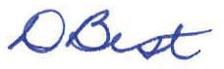
D Best Chair
Date: 30/08/2019

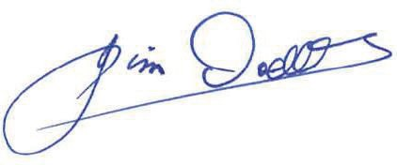
J Dodds
Chief Executive Officer Date: 30/08/2019

INDEPENDENT AUDITOR’S REPORT

To the Board of Safe Food Production Queensland

Report on the audit of the financial report
Opinion
I have audited the accompanying financial report of Safe food Production Queensland. In my opinion, the financial report:
- gives a true and fair view of the entity's financial position as at 30 June 2019, and its financial performance and cash flows for the year then ended;
- complies with the Financial Accountability Act 2009, the Financial and Performance Management Standard 2009 and Australian Accounting Standards.
The financial report comprises the statement of financial position as at 30 June 2019, the statement of comprehensive income, statement of changes in equity and statement of cash flows for the year then ended, notes to the financial statements including summaries of significant accounting policies and other explanatory information, and the management certificate.
Basis for opinion
I conducted my audit in accordance with the Auditor-General of Queensland Auditing Standards, which incorporate the Australian Auditing Standards. My responsibilities under those standards are further described in the Auditor’s Responsibilities for the Audit of the Financial Report section of my report.
I am independent of the entity in accordance with the ethical requirements of the Accounting Professional and Ethical Standards Board’s APES 110 Code of Ethics for Professional Accountants (the Code) that are relevant to my audit of the financial report in Australia. I have also fulfilled my other ethical responsibilities in accordance with the Code and the Auditor-General of Queensland Auditing Standards.
I believe that the audit evidence I have obtained is sufficient and appropriate to provide a basis for my opinion.
Other information
Other information comprises the information included in the entity’s annual report for the year ended 30 June 2019, but does not include the financial report and my auditor’s report thereon.
Those charged with governance are responsible for the other information.
My opinion on the financial report does not cover the other information and accordingly I do not express any form of assurance conclusion thereon.
In connection with my audit of the financial report, my responsibility is to read the other information and, in doing so, consider whether the other information is materially inconsistent with the financial report or my knowledge obtained in the audit or otherwise appears to be materially misstated.

If, based on the work I have performed, I conclude that there is a material misstatement of this other information, I am required to report that fact.
I have nothing to report in this regard.
Responsibilities of the entity for the financial report
The Board is responsible for the preparation of the financial report that gives a true and fair view in accordance with the Financial Accountability Act 2009, the Financial and Performance Management Standard 2009 and Australian Accounting Standards, and for such internal control as the Board determines is necessary to enable the preparation of the financial report that is free from material misstatement, whether due to fraud or error.
The Board is also responsible for assessing the entity's ability to continue as a going concern, disclosing, as applicable, matters relating to going concern and using the going concern basis of accounting unless it is intended to abolish the entity or to otherwise cease operations.
Auditor’s responsibilities for the audit of the financial report
My objectives are to obtain reasonable assurance about whether the financial report as a whole is free from material misstatement, whether due to fraud or error, and to issue an auditor’s report that includes my opinion. Reasonable assurance is a high level of assurance, but is not a guarantee that an audit conducted in accordance with the Australian Auditing Standards will always detect a material misstatement when it exists. Misstatements can arise from fraud or error and are considered material if, individually or in aggregate, they could reasonably be expected to influence the economic decisions of users taken on the basis of this financial report.
As part of an audit in accordance with the Australian Auditing Standards, I exercise professional judgement and maintain professional scepticism throughout the audit. I also:
    - Identify and assess the risks of material misstatement of the financial report, whether due to fraud or error, design and perform audit procedures responsive to those risks, and obtain audit evidence that is sufficient and appropriate to provide a basis for my opinion. The risk of not detecting a material misstatement resulting from fraud is higher than for one resulting from error, as fraud may involve collusion, forgery, intentional omissions, misrepresentations, or the override of internal control.
    - Obtain an understanding of internal control relevant to the audit in order to design audit procedures that are appropriate in the circumstances, but not for expressing an opinion on the effectiveness of the entity's internal control.
    - Evaluate the appropriateness of accounting policies used and the reasonableness of accounting estimates and related disclosures made by the entity.
    - Conclude on the appropriateness of the entity's use of the going concern basis of accounting and, based on the audit evidence obtained, whether a material uncertainty exists related to events or conditions that may cast significant doubt on the entity's ability to continue as a going concern. If I conclude that a material uncertainty exists, I am required to draw attention in my auditor’s report to the related disclosures in the financial report or, if such disclosures are inadequate, to modify my opinion. I base my conclusions on the audit evidence obtained up to the date of my auditor’s report.

However, future events or conditions may cause the entity to cease to continue as a going concern.
      - Evaluate the overall presentation, structure and content of the financial report, including the disclosures, and whether the financial report represents the underlying transactions and events in a manner that achieves fair presentation.
I communicate with the Board regarding, among other matters, the planned scope and timing of the audit and significant audit findings, including any significant deficiencies in internal control that I identify during my audit.
In accordance with s.40 of the Auditor-General Act 2009, for the year ended 30 June 2019:
- I received all the information and explanations I required.
- In my opinion, the prescribed requirements in relation to the establishment and keeping of accounts were complied with in all material respects.

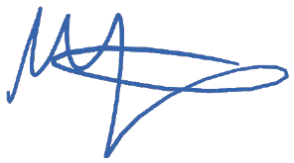 30 August 2019
Melissa Fletcher Queensland Audit Office
as delegate of the Auditor-General Brisbane

This page intentionally left blank

Attachment A compliance checklist

Summary of requirement |  | Basis for requirement | Annual report reference
Letter of compliance | A letter of compliance from the accountable officer or statutory body to the relevant Minister/s | ARRs – section 7 | Page 2
Accessibility | Table of contents Glossary | ARRs – section 9.1 | Page 1  Page 68
 | Public availability | ARRs – section 9.2 | Page 3
 | Interpreter service statement | Queensland Government Language Services Policy  ARRs – section 9.3 | Page 3
 | Copyright notice | Copyright Act 1968 ARRs – section 9.4 | Page 70
 | Information licensing | QGEA – Information Licensing  ARRs – section 9.5 | Page 70
General information | Introductory information | ARRs – section 10.1 | Page 7
 | Agency role and main functions | ARRs – section 10.2 | Page 7
 | Machinery of Government changes | ARRs – section 31& 32 | N/A
 | Operating environment | ARRs – section 10.3 | Page 7

Summary of requirement |  | Basis for requirement | Annual report reference
Non-financial  performance | Government’s objectives for the community | ARRs – section 11.1 | Page 7
 | Other whole-of-government plans /  specific initiatives | ARRs – section 11.2 | Page 7
 | Agency objectives and performance indicators | ARRs – section 11.3 | Page 7
 | Agency service areas and service standards | ARRs – section 11.4 | Page 30
Financial performance | Summary of financial performance | ARRs – section 12.1 | Page 38
Governance – management and structure | Organisational structure | ARRs – section 13.1 | Page 30
 | Executive management | ARRs – section 13.2 | Page 29
 | Government bodies (statutory bodies and other entities) | ARRs – section 13.3 | N/A
 | Public Sector Ethics Act 1994 | Public Sector Ethics Act 1994  ARRs – section 13.4 | Page 33
 | Queensland public service values | ARRs – section 13.5 | Page 29
Governance – risk management and accountability | Risk management | ARRs – section 14.1 | Page 31
 | Audit committee | ARRs – section 14.2 | Page 32
 | Internal audit | ARRs – section 14.3 | Page 32
 | External scrutiny | ARRs – section 14.4 | Page 61
 | Information systems and record keeping | ARRs – section 14.5 | Page 35
Governance – human resources | Strategic workforce planning and performance | ARRs – section 15.1 | Page 28
 | Early retirement, redundancy and retrenchment | Directive No.11/12 Early Retirement, Redundancy and Retrenchment  ARRs – section 15.2 | Page 28

Summary of requirement |  | Basis for requirement | Annual report reference
Open Data | Statement advising publication of information | ARRs – section 16 | Page 36
 | Consultancies | ARRs – section 33.1 | Page 36
 | Overseas travel | ARRs – section 33.2 | Page 36
 | Queensland Language Services Policy | ARRs – section 33.3 | N/A
Financial statements | Certification of financial statements | FAA – section 62 FPMS – sections 42, 43  and 50  ARRs – section 17.1 | Page 63
 | Independent Auditors Report | FAA – section 62 FPMS – section 50  ARRs – section 17.2 | Page 61

- FAA Financial Accountability Act 2009

- FPMS Financial and Performance Management Standard 2009

- ARRs Annual Report Requirements for Queensland Government Agencies

- QGEA Queensland Government Enterprise Architecture

Glossary

Accreditation
The legal instrument that authorises the production and/or processing of primary produce under the Food Production (Safety) Act 2000.

Application
An application for accreditation includes the prescribed fee, a description of the activities carried out or proposed to be carried out by the applicant in connection with the production of primary produce, and a copy of their food safety program or management statement.

Audit
A systematic, independent, official examination of evidence that is evaluated objectively to ‘call to account’ the holder of
accreditation for their food safety obligations.

Baseline
An initial set of measurements and observations that identify the most appropriate food safety interventions of a system.

Compliance
When a person or food business is operating within the regulatory requirements that apply to the activity in which they are engaged and in keeping with the baseline for that activity.

Food Production (Safety) Act 2000
The Food Production (Safety) Act 2000 is the legislation under which Safe Food operates. The Act aims to ensure that the production of primary produce is carried out in a way that:

- makes primary produce fit for human or animal consumption and maintains food quality

- provides for food safety measures for the production of primary produce consistent with other State laws relating to food safety.

Food safety program
A general term referring to any risk-based food safety management system, including legislated food safety programs.

Inspection
A formal or official viewing or examination of activities conducted by a business as part of their accreditation with Safe
Food.

Management statement
A document prepared by an individual or business outlining their business activities and how they control the food safety risks in their business.

Monitoring
Includes, but is not limited to, a method used to check, observe, or record the operation of a food business.

Processor
A processor is a person who undertakes processing activities as defined under Food Production (Safety) Act 2000.

Producer
A producer is a person who undertakes primary production activities under the Food Production (Safety) Act 2000.

Risk
In relation to food safety, a measure of the probability that a particular activity will result in unsafe or unsuitable food.

Supply chain
A series of steps or processes from the point of harvest or production through to the consumer. The supply chain can vary in length according to activities, time and travel distance.

Verification
The application of methods, procedures, tests and other tools for evaluation, in addition to monitoring, to determine compliance of a food safety program with the Food Standards Code or appropriate regulation.

Acronyms
ARR Annual Report Requirements

CAR Corrective Action Request

CAS Compliance Assessment System

CEO Chief Executive Officer

CIMS Central Information Management System DOA Australian Department of Agriculture
FAA Financial Accountability Act 2009
FPMS Financial and Performance Management Standard 2009

FSANZ Food Standards Australia New Zealand

IP Information Privacy

PASE Package Assisting Small Exporters

PIN Penalty Infringement Notice

PSA Preferred Supplier Arrangement

RTI Right to Information

Contact us

Safe Food Production Queensland
ABN 94 790 873 787

PO Box 221,
Greenslopes QLD 4120

T (07) 3253 9800 or Freecall 1800 300 815 (QLD only)
F (07) 3253 9810
E info@safefood.qld.gov.au
W www.safefood.qld.gov.au

Copyright
Annual Report 2018–19
© Safe Food Production Queensland 2019

Licence
This annual report is licensed by Safe Food Production Queensland under a Creative Commons Attribution (CC BY) 3.0 Australia Licence

Data
All figures presented in this Annual Report are accurate as of 30 June 2019, unless otherwise stated.

This page intentionally left blank

This page intentionally left blank

Safe Food Production Queensland Annual Report 2018-2019
www.safefood.qld.gov.au

